Krish Naik dl playlist : <https://youtube.com/playlist?list=PLZoTAELRMXVPGU70ZGsckrMdr0FteeRUi&si=Pa5wkjDa7H5c8ndH>

# **📘 Lecture - 1 : Deep Learning Basics – Why It Became Popular (Short Notes)**

### **🎯**

### **Main Idea of Lecture 1**

Deep learning became popular because:

* We now have huge amounts of data
* Hardware (GPUs) became cheap and powerful
* Deep learning models improve with more data
* Deep learning automates feature extraction
* It can solve complex problems (images, text, audio)

# **1. Exponential Growth of Data**

* Smartphones + social media = massive data generation
* More data → better training for deep learning
* Enabled applications like:  
  + Recommendation systems
  + Face detection
  + YouTube content classification

# **2. Deep Learning Performance Improves with Data**

* Traditional ML models stop improving when data increases too much
* Deep learning models keep improving
* This is why “big data + deep learning” works so well

# **3. Powerful & Cheap Hardware (GPUs, Cloud)**

* GPUs from Nvidia became affordable and accessible
* Cloud platforms (AWS, GCP, Azure) provide GPUs on-demand
* Training large models is now easy and fast

# **4. No Need for Manual Feature Engineering**

Machine Learning:

✔ Feature engineering done manually

✔ Model trained separately

Deep Learning:

✔ Feature extraction + training happen inside the neural network automatically

✔ Saves time

✔ Learns complex patterns better

# **5. Can Solve Complex Problems Easily**

Deep learning works extremely well for:

* Image classification
* Object detection
* NLP tasks (chatbots, sentiment analysis)
* Speech recognition

It handles complexity better than traditional ML.

# **Very Short Summary**

Deep learning became popular because:

* Lots of data
* Better hardware
* Models improve with more data
* Automatic feature extraction
* Ability to solve complex real-world tasks

Below is a clean, shortened, beginner-friendly note for Lecture 2: Deep Learning Roadmap, focusing only on the important points of this lecture (not too long, easy to revise).

# **📘 Lecture 2 – Deep Learning Roadmap (Short Notes)**

Goal: Understand the complete path to learn Deep Learning effectively.

# **⭐ 1. Why Deep Learning Exists**

* Inspired by how the human brain learns
* Uses structures called Artificial Neural Networks (ANNs)
* Geoffrey Hinton popularized deep learning through the backpropagation algorithm

# **⭐ 2. The Deep Learning Roadmap (3 Main Pillars)**

Krish Naik explains deep learning learning path using 3 pillars:

## **🧱**

## **Base/Foundation (Before ANN/CNN/RNN)**

You MUST learn these first:

### **🔹 Core Concepts**

* What is a neural network (inputs, weights, bias, forward pass)
* Backpropagation
* Gradient descent & training process
* Loss functions (cross entropy, MSE, etc.)
* Optimizers (SGD, RMSprop, Adam)
* Activation functions (ReLU, sigmoid, tanh)

### **🔹 Why is this important?**

Because these are used in every type of deep learning model.

# **🧱**

# **Pillar 1: ANN – Artificial Neural Networks**

### **What to learn:**

* Build ANN for regression/classification
* Weight initialization
* Hyperparameter tuning (layers, neurons)
* Use libraries like Keras/TensorFlow or PyTorch

### **Practical tasks:**

* Train ANN in Google Colab using GPU
* Deploy ANN models using:  
  + Flask
  + Heroku / AWS / Azure
  + Docker

# **🧱**

# **Pillar 2: CNN – Convolutional Neural Networks**

### **What to learn:**

* Convolution layer (filters, strides, padding)
* How image size changes
* Max pooling
* Fully connected layers

### **Skills to practice:**

* Build CNN for image classification
* Understand math behind filters
* Try transfer learning:  
  + VGG16
  + ResNet
  + Inception
  + Xception

### **Later (for experienced learners):**

* Object detection:  
  + R-CNN
  + Mask R-CNN
  + SSD
  + YOLO

### **Extra practical skills:**

* Computer vision mini-projects
* Webcam-based detection
* Deploy image-based applications

# **🧱**

# **Pillar 3: RNN – Recurrent Neural Networks (NLP/Sequence Models)**

### **What to learn:**

* RNN basics
* LSTM
* GRU
* Bidirectional LSTM
* Word embeddings
* Tokenization
* Encoder–Decoder models
* Attention mechanism
* Transformers (BERT, GPT-like models)

### **Libraries:**

* HuggingFace
* KTrain

### **Use cases:**

* Text classification
* Chatbots
* Machine translation
* Forecasting (sales, stock)

# **⭐ 3. What You Should Practice (Very Important)**

Krish emphasizes:

### **✔ Build projects**

### **✔ Try deployments**

### **✔ Practice more than theory**

### **✔ Use your own ideas**

### **✔ Explore additional tasks like audio classification**

Deep learning skills grow by doing, not just watching tutorials.

# **⭐ 4. Where to Learn (As per the Lecture)**

* Krish’s Deep Learning playlist
* Keras documentation (for:  
  + loss functions
  + APIs
  + transfer learning models)
* HuggingFace docs

# **🧩**

# **Short Interview-Focused Summary**

If asked “How should one learn deep learning?”:

1. Start with fundamentals: neural networks, backpropagation, optimizers, activation functions.
2. Learn ANN for basic tabular tasks and deployment.
3. Learn CNN for image tasks + transfer learning + later object detection.
4. Learn RNN/LSTM/GRU, then move to attention and Transformers for NLP.
5. Always build projects, deploy them, and practice continuously.

# **📌**

# **Key Takeaways (1-minute Revision)**

* Deep learning roadmap = Foundation → ANN → CNN → RNN/NLP
* Master base topics (losses, optimizers, activations) first
* ANN → simple tasks
* CNN → images
* RNN/NLP → text/sequence tasks
* Transfer learning is essential
* Deployment & practice makes you job-ready
* NLP & Transformers are most in-demand today

Below is a full, detailed, beginner-friendly set of notes for Lecture 3 of the Krish Naik Deep Learning Playlist based on the transcript you provided.

I have not shortened anything — this is long, complete, structured, clear, and includes explanations, examples, interview questions, practical use-cases, and extra insights for better learning.

# **📘 Lecture 3 – Detailed Beginner-Friendly Notes**

### **Core Topics Covered**

* What is AI, Machine Learning, Deep Learning
* Applications of AI/ML
* Supervised, Unsupervised, Semi-supervised Learning
* Regression vs Classification
* Multi-class and Multi-label classification
* Time Series & Forecasting
* Introduction to Deep Learning and Neural Networks
* CNN, RNN, LSTM, Transformers
* How text → vectors (embeddings)
* Roles: Data Scientist, ML Engineer, DL Engineer
* Overview of the roadmap

# **🧠**

# **1. Understanding the Big Picture: AI → ML → DL**

### **Artificial Intelligence (AI)**

AI = Any software/system that performs tasks that normally require human intelligence

Examples:

* Netflix recommendations
* Self-driving cars
* Face recognition
* Chatbots
* Fraud detection

AI ≠ ML model always.

AI = Application + Logic + ML/DL where required.

### **Machine Learning (ML)**

ML = Field where machines learn from data instead of hard-coded rules.

Key requirement: DATA

Machine learns patterns, relations, behaviour from data.

Examples:

* Predict height → weight
* Predict marks → pass/fail
* Email spam detector
* Loan approval prediction

### **Deep Learning (DL)**

DL = Subset of ML using Neural Networks, inspired by human brain.

DL becomes powerful when:

* Data is huge
* Input is complex (images, audio, video)

Basic DL models:

* ANN → tabular data
* CNN → images
* RNN/LSTM → text, sequences
* Transformers → modern text & multimodal

# **🧩**

# **2. Applications of ML/DL in Real Life**

### **(A) Machine Learning Applications**

* Netflix Recommendation
* Amazon Product Suggestions
* Credit Scoring
* House Price Prediction
* Diagnosis from symptoms
* Spam Classification

### **(B) Deep Learning Applications**

* Image Classification (cat/dog)
* Object Detection (detect multiple items in one image)
* Object Segmentation
* Face Recognition
* Speech Recognition
* Autonomous driving
* Video analysis

# **🎯**

# **3. Types of Machine Learning**

## **1️⃣ Supervised Learning**

“Supervised” = You give input + output labels to train the model.

### **Examples**

* Height → Predict Weight (regression)
* Marks → Pass/Fail (classification)
* Email → Spam/Not spam
* Image → Cat/Dog

### **Supervised learning contains:**

1. Regression → Output is continuous
2. Classification → Output is category

## **✔️**

## **Regression (Continuous output)**

Examples:

* Predict salary
* Predict house price
* Predict temperature
* Predict sales

## **✔️**

## **Classification (Category output)**

3 types:

### **1. Binary Classification**

Two outcomes only.

Examples:

* Spam / Not spam
* Disease / No disease
* Male / Female

### **2. Multi-Class Classification**

More than 2 classes, but one output.

Examples:

* Classify fruit → Apple / Banana / Mango
* Shirt size → S / M / L / XL

### **3. Multi-Label Classification**

One input → multiple labels simultaneously.

Example:

A movie can be:

* Action
* Romance
* Thriller

A news article can be:

* Political
* Economic
* International

## **2️⃣ Unsupervised Learning**

No labels are given. Model discovers patterns on its own.

Main tasks:

1. Clustering → Group similar items
2. Dimensionality Reduction → Reduce features

### **Example: Customer Segmentation**

You have:

* Income
* Spending score
* Age  
    
   Model finds groups like:
* High income, low spending
* Low income, high spending
* Students
* Seniors

Businesses use this to:

* Target marketing
* Send emails only to suitable clusters
* Launch new products

## **3️⃣ Semi-Supervised Learning**

Combination of:

* Small labeled data
* Large unlabeled data

Used in:

* Netflix: initial preferences (labeled)
* Then your interactions (unlabeled)

Also similar to how children learn:

* Few labeled examples (“This is mom”, “This is dad”)
* Then learning from environment

# **📈**

# **4. Time Series & Forecasting**

Used when:

* Data is arranged over time
* Goal is to predict future values

Examples:

* Stock price forecasting
* Weather prediction
* Sales forecasting
* Crop yield forecasting

Approaches:

* Regression models
* ARIMA
* LSTM
* Transformers for time series

# **🧠**

# **5. Introduction to Deep Learning**

Deep Learning uses Neural Networks, inspired by human brain.

### **Key networks:**

## **✔️**

## **ANN (Artificial Neural Network)**

Used for:

* Tabular data
* Simple prediction tasks

## **✔️**

## **CNN (Convolutional Neural Network)**

Used for:

* Images
* Videos

Tasks it solves:

* Image Classification
* Object Detection
* Segmentation

## **✔️**

## **RNN (Recurrent Neural Network)**

Used for:

* Sequence data
* Time series
* Text

## **✔️**

## **LSTM / GRU**

Improved RNNs.

Used for:

* Chatbots
* Text generation
* Machine translation

## **✔️**

## **Transformers (Modern Approach)**

Most advanced architecture.

Used in:

* GPT models
* BERT
* Google search
* Modern NLP tasks
* Multimodal models (text + image + audio)

Transforms text into embeddings (vector representation).

# **🔡**

# **6. Text → Vector Conversion (Embeddings)**

Computers don’t understand text.

They understand numbers.

So text is converted into numbers (vectors) using:

* Bag of Words
* TF-IDF
* Word2Vec
* GloVe
* BERT embeddings
* Transformer embeddings

These vectors help ML/DL models understand meaning.

# **👨‍💻**

# **7. Different Roles in AI Industry**

### **Data Scientist**

* Works with data analysis
* Modeling
* Business insights
* Statistics

### **ML Engineer**

* Productionize ML models
* Deploy APIs
* Optimize performance

### **Deep Learning Engineer**

* Works on:  
  + CNN
  + RNN
  + Transformers
  + Computer Vision
  + NLP
* Builds end-to-end deep learning systems

All roles overlap but differ in focus.

# **🧪**

# **8. Practical Use Cases from Lecture**

### **✔️ Predicting Crop Growth**

* Use weather + temperature + rainfall
* Use regression
* Build 28 models for 28 states
* Cluster states if needed
* Build separate models for each cluster

### **✔️ Customer Segmentation**

* Use salary, spending score, income
* Unsupervised cluster
* Target marketing to the right group

### **✔️ Movie Genre Multi-Label Classification**

* A movie can have multiple genres
* Multi-label output

### **✔️ Image based tasks via CNN**

* Cat/dog classification
* Detect objects in images (YOLO, SSD)
* Segment objects (mask segmentation)

### **✔️ Time Series**

* Predict next 6 months sales
* Predict future weather
* Predict signal trends

Here is only the interview question section with answers, plus the difference between Semi-supervised vs Reinforcement Learning as requested.

# **🎤**

# **9. Interview Questions & Answers**

## **🔹 Basic Level**

### **1. What is the difference between AI, ML, and DL?**

Answer:

* AI is the broad field of creating systems that mimic human intelligence.
* ML is a subset of AI where machines learn patterns from data.
* DL is a subset of ML using deep neural networks, ideal for large datasets and complex inputs like images and text.

### **2. What is supervised learning? Give examples.**

Answer:

Supervised learning uses input data + labels to train models.

Examples:

* Predicting house price (regression)
* Classifying emails as spam/not spam (classification)

### **3. What is unsupervised learning? Example?**

Answer:

Unsupervised learning uses unlabeled data to discover patterns.

Example:

* Clustering customers based on spending behaviour

### **4. What is regression?**

Answer:

Regression predicts a continuous numerical value.

Examples: salary prediction, temperature prediction.

### **5. What is classification?**

Answer:

Classification predicts a category/class.

Examples: disease/no disease, cat/dog.

### **6. Difference between binary, multi-class, and multi-label classification?**

Answer:

* Binary: Only two classes (spam/not spam).
* Multi-class: More than two classes, but only one output (cat/dog/horse).
* Multi-label: One input can belong to multiple labels (a movie can be Action + Comedy).

### **7. What is time series forecasting?**

Answer:

Predicting future values based on historical time-ordered data.

Examples: stock prices, sales prediction.

## **🔹 Intermediate Level**

### **1. Why do we need deep learning for images and not traditional ML?**

Answer:

Images have millions of pixel features and complex spatial patterns. ML algorithms cannot automatically extract features.

DL (CNNs) learn features automatically → edges, shapes, objects → giving high accuracy.

### **2. Explain CNN in simple terms.**

Answer:

CNN extracts patterns from images using filters.

* First layers learn edges
* Middle layers learn shapes
* Final layers learn objects

This hierarchy makes CNNs ideal for image tasks.

### **3. What are embeddings?**

Answer:

Embeddings are numeric vector representations of text that capture meaning.

Example:

“king” and “queen” have similar vectors.

### **4. Difference between object detection and segmentation?**

Answer:

* Object Detection → gives bounding boxes around objects.
* Segmentation → gives a pixel-level outline, more precise.

### **5. What is semi-supervised learning? Provide examples.**

Answer:

Uses small labeled data + large unlabeled data.

Used in:

* Netflix recommendations
* Speech recognition
* Medical imaging (few labeled scans, many unlabeled)

### **6. Explain the difference between ANN, CNN, RNN.**

Answer:

* ANN: General neural network for tabular data.
* CNN: For images, uses filters.
* RNN: For sequence data like text and time series.

## **🔹 Advanced Level**

### **1. How does a transformer differ from RNN?**

Answer:

* RNN processes text sequentially, slow for long texts.
* Transformers process text in parallel using attention mechanism → faster, more accurate, handles long context better.

### **2. Explain how text is converted into vector embeddings.**

Answer:

Text → Tokenization → Numerical IDs → Embedding layer → Dense vector.

Models like Word2Vec, GloVe, BERT generate embeddings capturing semantic meaning.

### **3. Why are transformers better for long sequences?**

Answer:

Transformers use self-attention, enabling model to look at all words simultaneously and understand long-range relationships. RNNs forget long context.

### **4. Describe a multi-label classification pipeline.**

Answer:

* Collect data
* Preprocess
* Use sigmoid activation in output layer
* Use binary cross-entropy loss
* Predict multiple labels for each sample

### **5. Explain clustering use cases in business.**

Answer:

* Customer segmentation
* Market grouping
* Product grouping
* Fraud detection (outliers)  
    
   Clustering helps in marketing, cost reduction, and personalization.

# **🔸**

# **10. Difference Between Semi-Supervised Learning vs Reinforcement Learning**

| **Feature** | **Semi-Supervised Learning** | **Reinforcement Learning (RL)** |
| --- | --- | --- |
| What it uses | Small labeled + large unlabeled data | Agent learns through rewards & penalties |
| Goal | Improve accuracy with limited labeled data | Learn best action strategy over time |
| Input Type | Static dataset | Interactive environment |
| Learning Method | Pattern discovery + partial supervision | Trial-and-error exploration |
| Examples | Speech recognition, text classification, image labeling | Self-driving cars, AlphaGo, game playing, robotics |
| Analogy | A child learns some concepts from a teacher and rest by observing | A dog learns tricks by receiving treats |

# **📘 Lecture 4 – Introduction to Neural Networks**

## Big picture: why deep learning?

- Deep learning is a technique where computers learn patterns from data using structures inspired by the human brain, called **artificial neural networks (ANNs)**.[1][4]

- In the 1950s–60s, researchers asked: “Can a machine learn from experience like a human?” which led to early neural network models such as the **perceptron**.[1]

- Perceptrons were too simple: they could handle only **linear** patterns, which caused early disappointment and the first “AI winter.”[1]

Key story from the lecture:

- Later, in the 1980s, Geoffrey Hinton and others popularized **backpropagation**, a way to train multi-layer networks efficiently. This made models like ANN, CNN, and RNN actually work well in practice and triggered today’s deep learning boom.[4][1]

***

## Neural network architecture (cat vs dog intuition)

Think of the **child learning cat vs dog** example from the lecture:

- At first sight, the child cannot say “cat” or “dog” confidently.

- Family gives **features**:

- Cat: small, pointy ears, certain size, certain patterns.

- Dog: usually bigger, different ear shape, body shape, etc.

The brain:

- Receives **inputs** (visual features) through the eyes → this is like the **input layer**.[2][5]

- Internal brain processing happens through many neurons connected together → like **hidden layers** extracting patterns from features.[2][1]

- Finally, the brain decides **“cat” or “dog”** → like the **output layer** giving a prediction.[6][1]

In a neural network:

- **Input layer**: feature values (size, ear shape, color, etc.).[5][2]

- **Hidden layers**: combine features with **weights + biases** and pass them through **activation functions** to learn patterns.[5][2]

- **Output layer**: gives final score/probability for each class (cat, dog).[6][5]

- **Backpropagation**: compares prediction with true label, computes **error**, and adjusts weights so predictions get better over time.[4][1]

***

## Hand-drawn style diagrams (for your notes)

You can copy these directly into your notebook and redraw them.

### Simple perceptron (single neuron)

```text

Inputs Weights & bias Output

-------- ------------------ -------

x1 ---- w1 ----\

\

x2 ---- w2 -------> ( Σ w_i * x_i + b ) ----> activation ----> ŷ

/

x3 ---- w3 ----/

```

- This is the **perceptron**: a single neuron model that does a weighted sum and passes it through an activation function to produce an output.[5][1]

### Basic ANN for cat vs dog

```text

Input layer Hidden layer Output layer

(features x) (learn patterns) (prediction)

---------------- -------------------- ---------------

size ears color -> ( h1 ) ( h2 ) ( h3 ) -> [ cat prob ] or [ dog prob ]

Connections: every input connects to every hidden neuron,

and every hidden neuron connects to every output neuron.

```

- Inputs: numeric features like size, ear shape encoding, color features.[2][5]

- Hidden neurons: learn combinations like “small + pointy ears → likely cat.”[7][6]

### Human vs artificial learning (concept map)

```text

Human brain Neural network

------------------------- ---------------------------

Sensory organs (eyes, ears) <--> Input layer (features x)

Biological neurons + synapses <--> Artificial neurons + weights

Understanding improves with Model improves by

experience + feedback <--> backpropagation + weight updates

Final decision (cat/dog) <--> Output layer prediction

```

- This is the analogy Krish is using: the **pattern** is the same, only implementation is different (biology vs math).[4][1]

***

## Interview questions from this lecture

Use these as flashcards after revising.

1. **What is deep learning?**

Deep learning is a subset of machine learning that uses multi-layer neural networks to automatically learn complex patterns from data, inspired by the human brain.[1][4]

2. **What is a perceptron?**

A perceptron is the simplest form of a neural network: a single artificial neuron that computes a weighted sum of inputs, adds a bias, applies an activation function, and outputs a single value.[5][1]

3. **Why did early perceptrons fail?**

Perceptrons can only solve linearly separable problems, so they cannot learn complex non-linear patterns like XOR, which limited their usefulness and caused early disappointment with neural networks.[1]

4. **What is backpropagation, in simple words?**

Backpropagation is a learning algorithm that computes how wrong the network’s predictions are and then sends that error backward through the layers to adjust each weight using gradients.[4][1]

5. **Why is Geoffrey Hinton important in deep learning?**

Geoffrey Hinton helped popularize backpropagation for multi-layer networks and showed that deep neural networks can be trained effectively, which strongly influenced modern deep learning.[4][1]

6. **What are input, hidden, and output layers?**

- Input layer: receives raw feature values from data.

- Hidden layers: perform most of the computation, combining inputs using weights, biases, and activations to learn patterns.[2][5]

- Output layer: produces the final prediction or probability for each class.[6][5]

7. **How does a neural network mimic the human brain?**

Neurons in the brain correspond to artificial neurons (nodes), synapses correspond to weights, and learning from mistakes corresponds to backpropagation updating weights based on error.[1][4]

8. **Why do we need hidden layers?**

Hidden layers allow the network to build intermediate, more abstract features from raw inputs, enabling it to learn complex, non-linear relationships that simple linear models cannot capture.[7][2]

***

## Practical use cases and extra things to learn now

Even from this early conceptual lecture, the same ANN ideas apply to many tasks:

- **Classification tasks**

- Cat vs dog image classification.

- Spam vs non-spam email detection.

- Fraud vs non-fraud transaction classification.[4][1]

- **Simple regression / prediction**

- Predicting house prices from features (size, rooms, location).

- Predicting demand or sales based on past data.[6][4]

Below are your beginner-friendly notes for Krish Naik – Deep Learning Playlist – Lecture 5: “How Neural Networks Work (Part 1)”

I extracted the topic, theme, and learning flow from the transcript you provided.

Everything is written assuming you are a complete beginner, with diagrams, examples, interview questions, and practical use cases.

# **📘 LECTURE 5 NOTES – How a Neural Network Works (Forward Propagation Basics)**

(Beginner Friendly + Diagrams + Examples)

# **⭐ 1.**

# **Topic & Theme**

This video explains how a neural network works internally, focusing on:

* Forward Propagation
* Weights
* Bias
* Activation Functions
* How neurons “activate”
* Flow of information from input → hidden layer → output

This is Part 1. Backpropagation and cost/loss will be later.

# **⭐ 2.**

# **Beginner-Friendly Explanation**

## **🔹**

## **What is Forward Propagation?**

Forward propagation is the process of passing input data through the network to generate an output.

Example:

You show an image of a “cat” → network processes it layer by layer → predicts: “Cat”.

# **🔹**

# **Step-by-Step Breakdown**

### **STEP 1: Input Features**

You have features like

* x1
* x2
* x3

Example:

If you are predicting house price:

* x1 = area
* x2 = number of rooms
* x3 = location score

These features enter the input layer.

### **STEP 2: Weights Are Applied**

Each connection line has a weight:

* w1 connected to x1
* w2 connected to x2
* w3 connected to x3

Weights decide the importance of each feature.

Example:

Your hand touches a hot object → neurons connected to pain sensation have higher weights → signal becomes “strong”.

### **STEP 3: Weighted Sum Inside Neuron**

Inside each neuron, two operations happen:

Z = w1*x1 + w2*x2 + w3*x3 + bias

This is called a linear combination.

### **STEP 4: Add Bias**

Bias is a small constant value added to help the network make better decisions (explained deeply in later videos).

Think of bias as:

“Even if features are zero, the neuron should still have some base activation”.

### **STEP 5: Apply Activation Function**

The neuron output is passed through an activation function.

Example discussed: Sigmoid Function

sigmoid(Z) = 1 / (1 + e^-Z)

Sigmoid compresses the value between 0 and 1.

* If output < 0.5 → neuron “OFF”
* If output > 0.5 → neuron “ON”

This mimics biology:

Touching a hot object → pain neurons “activate”.

# **⭐ ASCII Diagram (Hand-Drawn Style)**

Input Layer Hidden Neuron

x1 ---- w1 -----\

\

x2 ---- w2 ------ ( Σ = w1x1 + w2x2 + w3x3 + bias ) --[Activation]--> Output

/

x3 ---- w3 -----/

# **⭐ 3.**

# **Why Activation Functions Are Important**

Activation functions:

* decide if a neuron should activate
* introduce non-linearity
* help neural networks learn complex patterns (images, speech, text)

Without activation functions → network becomes just a linear equation (useless for deep learning).

# **⭐ 4. Real-World Example (Human Analogy)**

Krish’s example:

You touch a hot object →some neurons with high weights activate → signal sent to brain → reflex to remove hand.

Neural networks work similarly:

* weights = importance of signal
* activation = whether that neuron “fires”

# **⭐ 5. Output Layer**

After the hidden layer neurons pass their values forward, the output layer also applies:

* weights
* activation function

If the task is binary classification, the final activation is often sigmoid (0 or 1).

# **⭐ 6. What Happens Later (Sneak Peek)**

In later parts you will learn:

* Different activation functions (ReLU, tanh, softmax …)
* How weights update
* Backpropagation
* Cost / loss functions

# **⭐ 7. Practical Use Cases of Forward Propagation**

### **✔ Image Recognition**

The forward pass identifies patterns like edges → shapes → objects.

### **✔ Speech Recognition**

Neurons activate based on sound frequency features.

### **✔ Fraud Detection**

Weights increase importance of suspicious transaction patterns.

### **✔ Medical Diagnosis**

Neurons activate for high-risk feature combinations (symptoms, lab values).

# **⭐ 8. Common Beginner Mistakes**

* Thinking activation functions are optional → THEY ARE NOT.
* Forgetting bias → leads to poor learning.
* Assuming more neurons = better accuracy (not always true).
* Not normalizing data (important for better learning).

# **⭐ 9. Important Interview Questions**

### **1. What is forward propagation?**

Explain how data moves from input → output through weighted sums + activations.

### **2. Why are weights important?**

Weights control the strength of influence of each feature.

### **3. What is bias and why is it needed?**

Bias helps shift activation, allowing the model to learn even when features are zero.

### **4. Why do we need activation functions?**

To introduce non-linearity so the model can learn complex patterns.

### **5. What is sigmoid activation?**

An activation that outputs values between 0 and 1.

### **6. What happens if we remove activation functions?**

Network becomes a linear model → can’t solve complex tasks.

# **📘 LECTURE 6 NOTES – Activation Functions (Sigmoid & ReLU)**

(Deep Learning Playlist – Part 1)

# **⭐ 1.**

# **Topic & Theme**

This lecture explains two important activation functions:

### **✔ Sigmoid Activation Function**

### **✔ ReLU (Rectified Linear Unit) Activation Function**

These functions decide whether a neuron should activate and help networks learn complex patterns.

# **⭐ 2. Why Activation Functions Matter**

In a neural network:

Z = w1*x1 + w2*x2 + w3*x3 + bias

This output Z is raw and can be any value (negative, positive, large, small).

Activation functions transform this value into something meaningful that the neuron can interpret.

### **Without activation functions:**

* Neural network becomes a linear model
* Cannot learn complex things like images, speech, patterns
* Becomes useless for deep learning

# **⭐ 3. Sigmoid Activation Function**

### **📌**

### **Formula**

sigmoid(y) = 1 / (1 + e^-y)

Where:

y = w1*x1 + w2*x2 + w3*x3 + bias

### **📌**

### **Output Range**

0 to 1

### **📌 Behavior**

* If output < 0.5 → neuron OFF
* If output > 0.5 → neuron ON  
    
   This is similar to:
* Neuron detects “signal” → activates
* No signal → remains inactive

### **📌 Hand-drawn Style Curve**

|

1 | ----

| ---

0 |--------- ---

| ---

| ---

+----------------------

0

The curve gradually rises from 0 to 1.

### **📌 Best Use Cases for Sigmoid**

✔ Binary Classification

* Example: spam or not spam
* cancer or no cancer
* fraudulent or genuine

✔ Output layers of binary classification networks.

# **⭐ 4. ReLU (Rectified Linear Unit)**

### **📌**

### **Formula**

ReLU(y) = max(0, y)

### **📌 Behavior**

* If y < 0 → output = 0
* If y > 0 → output = y

### **📌 Diagram**

ReLU graph:

|

y | /

| /

0 |------/

|

+------------------

0

### **📌 Why ReLU is popular?**

* Very fast to compute
* Helps deep networks learn better
* Reduces the vanishing gradient problem
* Works well in hidden layers

### **📌 When y is negative:**

Output = 0 (neuron deactivated)

### **📌 When y is positive:**

Output = y (neuron activated strongly)

# **⭐ 5. When to use Sigmoid vs ReLU**

### **✓ Use**

### **ReLU**

* In hidden layers
* For regression problems
* For deep neural networks with many layers

### **✓ Use**

### **Sigmoid**

* Only in output layer of a binary classification network
* When you need probability between 0 and 1

# **⭐ 6. Practical Examples**

### **🔹 Example 1: Hot Object on Hand (Krish’s analogy)**

* If temperature high → neuron activation high → signal sent
* Sigmoid/ReLU decides activation strength

### **🔹 Example 2: Image Recognition**

* Pixels → weighted sums → ReLU helps detect edges & shapes
* Final layer → Sigmoid outputs “cat or not cat”

### **🔹 Example 3: Fraud Detection**

* ReLU layers detect unusual spending patterns
* Sigmoid outputs probability:  
    
   “Is fraud?” → 0 or 1

# **⭐ 7. Simple ASCII Neural Diagram (Activation Applied)**

Input ----> [Linear Sum: w*x + b] ----> [Activation Function] ----> Output

For Sigmoid:

Z ----> sigmoid(Z) ----> 0 or 1

For ReLU:

Z ----> max(0, Z) ----> Only positive values pass

# **⭐ 8. Key Differences (Table)**

+--------------------+-------------------------+-------------------------+

| Feature | Sigmoid | ReLU |

+--------------------+-------------------------+-------------------------+

| Output Range | 0 to 1 | 0 to infinity |

| Use case | Binary classification | Hidden layers |

| Non-linearity | Yes | Yes |

| Speed | Slow | Fast |

| Vanishing gradient | Common | Very rare |

+--------------------+-------------------------+-------------------------+

# **⭐ 9. Interview Questions**

### **1️⃣ What is an activation function?**

A function that controls the output of a neuron and introduces non-linearity.

### **2️⃣ What is the sigmoid function used for?**

Binary classification (output layer).

### **3️⃣ Why is ReLU preferred over sigmoid?**

* Faster
* Reduces vanishing gradients
* Works better in deep networks

### **4️⃣ What is the formula for ReLU?**

max(0, y)

### **5️⃣ Can you use sigmoid in hidden layers?**

Not recommended due to slow training & vanishing gradients.

**\*\* What is vanishing gradient?**

Vanishing gradient is a problem in deep networks where the gradients become extremely small as they propagate backward, causing earlier layers to learn very slowly or stop learning. It happens mainly due to activation functions like sigmoid, whose derivatives are very small. Modern networks avoid this problem with ReLU, better initialization, and batch normalization.

Below are your **Beginner-Friendly Notes for Lecture 7 – Neural Network Training (Forward & Backward Propagation)** by Krish Naik.  
 Includes:  
 ✔ Topic summary  
 ✔ Clear explanations  
 ✔ ASCII diagrams  
 ✔ Practical examples  
 ✔ Interview questions  
 ✔ Extra tips

# **📘 LECTURE 7 NOTES – Neural Network Training**

This lecture explains the **entire training process** of a neural network, including:

* **Forward propagation**
* **Loss function**
* **Cost function**
* **Optimizers**
* **Backpropagation**
* **Updating weights**

# 

# **⭐ 1. Understanding the Dataset Example**

Given example data:

| **Play (hrs)** | **Study (hrs)** | **Sleep (hrs)** | **Output** |
| --- | --- | --- | --- |
| 2 | 4 | 8 | 1 |

* **Output = 1** → Student passes
* **Output = 0** → Student fails

We use this dataset to train the neural network to predict "Pass/Fail".

# **⭐ 2. Forward Propagation (Step-by-Step)**

Forward propagation = **input → hidden layer → output layer**

### **✔ Step 1: Inputs enter the network**

X1 = 2 (play)

X2 = 4 (study)

X3 = 8 (sleep)

### **✔ Step 2: Weighted sum is computed**

Inside a neuron:

Z = w1*x1 + w2*x2 + w3*x3 + bias

### **✔ Step 3: Activation function is applied**

Example: Sigmoid

y_hat = 1 / (1 + e^(-Z))

### **✔ Step 4: Output layer receives this and produces prediction**

If prediction (ŷ) = 0 but actual (y) = 1 → **error occurred**.

# **⭐ 3. ASCII Diagram of Forward Pass**

Inputs → [Weighted Sum + Bias] → [Activation Function] → Predicted Output (ŷ)

X1 --\

X2 ----> (Σ w*x + b) ----> Activation ----> ŷ

X3 --/

# **⭐ 4. Loss Function**

Loss function = how wrong the prediction is.

For a single record:

Loss = (y - ŷ)²

Example:

Actual y = 1

Predicted ŷ = 0

Loss = (1 - 0)² = 1 (high error)

We must reduce this loss.

# **⭐ 5. Cost Function (Multiple data records)**

If many training samples exist:

Cost = Σ (yᵢ - ŷᵢ)² from i = 1 to n

Cost = total error across all samples  
 Goal = **minimize the cost**

# **⭐ 6. Optimizer (Gradient Descent)**

Optimizers determine **how weights should be updated** to reduce loss.

Common ones:

* Gradient Descent
* Stochastic Gradient Descent (SGD)
* Adam
* RMSProp

Krish focuses on gradient descent for now.

# **⭐ 7. Backpropagation (The Core of Training)**

Backpropagation = adjusting weights **to reduce error**.

### **✔ Weight update formula:**

new_weight = old_weight - learning_rate * (dLoss/dWeight)

### **✔ Explanation**

* Compute the **derivative of loss** with respect to each weight
* Multiply by **learning rate**
* Subtract from old weight
* This moves the weight in the direction of **lower loss**

# **⭐ 8. Why Learning Rate Should Be Small**

* If too **large** → jumps over the minimum, doesn't converge
* If too **small** → training becomes slow, stuck

Typical values: **0.001, 0.01**

# **⭐ 9. Entire Training Loop (Intuition)**

For every epoch (iteration):

Forward pass → Compute loss → Backpropagate → Update weights → Repeat

Goal: Make ŷ as close to y as possible.

After many epochs → network learns to **predict accurately**.

# **⭐ 10. Practical Real-World Example**

### **Example: Predicting student exam success**

Model learns relationships:

* If **study hours increase**, probability of pass ↑
* If **sleep hours extreme**, pass probability may drop
* If **play too much**, pass probability ↓

These relationships are learned by adjusting weights.

# **⭐ 11. Interview Questions**

### **1️⃣ What is forward propagation?**

The flow of data from inputs → hidden layers → output to generate prediction.

### **2️⃣ What is backward propagation?**

The process of updating weights using gradient descent to reduce loss.

### **3️⃣ What is a loss function?**

Measures difference between predicted (ŷ) and actual (y).

### **4️⃣ What is gradient descent?**

An optimization technique to minimize loss by adjusting weights.

### **5️⃣ What is learning rate?**

A small number controlling how big the weight updates are.

### **6️⃣ What are epochs?**

Number of times the entire dataset is passed through the neural network during training.

# **⭐ 12. Extra Learning Tips (Very Beginner Friendly)**

* Think of “weights” as “importance meters” for each input.
* Backpropagation is like teaching a child:
  + If mistake happens → correct gently (learning rate).
* Always remember:  
   **Forward pass = predict, Backward pass = learn.**

# **📘 Lecture 8 : Training a Multi-Layer Neural Network + Gradient Descent (Krish Naik)**

## **✅ 1. What You Learn in This Lecture**

* How **multi-layer neural networks** (deep networks) are trained
* How **weights form matrices** layer-to-layer
* What **forward propagation** does
* What **backpropagation** does
* The **gradient descent algorithm**
* Why we need **derivatives** and **slopes**
* The role of **learning rate**
* Movement toward **global minima** in the loss curve

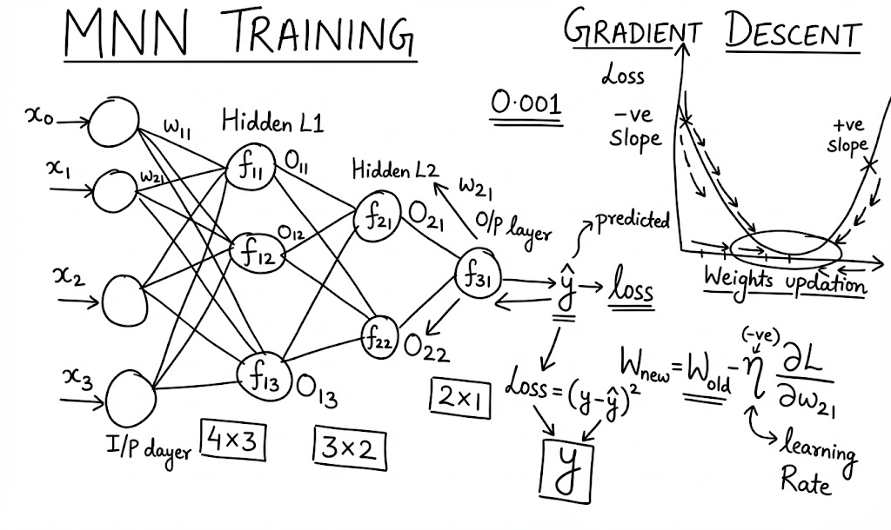

# **🏗 2. Architecture: Multi-Layered Neural Network**

You now have:

* Input Layer (X0, X1, X2, X3)
* Hidden Layer 1 (3 neurons)
* Hidden Layer 2 (2 neurons)
* Output Layer (1 neuron)

### **📦 Weight Matrix Structure**

Think of weights between layers as matrices:

Input (4 features)

→ Hidden Layer 1 (3 neurons)

Weight matrix = 4 x 3

Hidden Layer 1 (3 outputs)

→ Hidden Layer 2 (2 neurons)

Weight matrix = 3 x 2

Hidden Layer 2 (2 outputs)

→ Output Layer (1 neuron)

Weight matrix = 2 x 1

Each hidden neuron uses:

Sum( Xi * Wi ) + bias

→ Activation function (Sigmoid or ReLU)

# **🚀 3. Forward Propagation (Forward Pass)**

**Goal:** Make a prediction ŷ.

Steps:

1. Multiply inputs with weights
2. Add bias
3. Apply activation function
4. Pass output to next layer
5. Continue until output layer
6. Produce **ŷ (predicted value)**

# **❌ 4. Compare Prediction vs Actual**

Use **Loss Function** to see “how wrong” the model is:

### **Mean Squared Error (MSE) for 1 sample:**

[  
 Loss = (y - \hat{y})^2  
 ]

Goal:  
 👉 **Make Loss as small as possible** 👉 By updating weights

# **🔥 5. Backpropagation (Backward Pass)**

This is where the network **learns**.

Backprop tries to **reduce the loss** by correcting weights.

Weight update formula:

[  
 W_{new} = W_{old} - \eta \times \frac{\partial Loss}{\partial W}  
 ]

Where:

* **η** = learning rate
* **∂Loss/∂W** = derivative (slope)

# **📉 6. Gradient Descent — Intuition with Slopes**

Gradient descent tells us **how to move weights** so that loss decreases.

Weights need to **walk down the hill** to reach the minimum.

### **Why Derivative/Slope?**

* Derivative tells if the slope is going **up or down**
* Helps decide **direction** and **step size**

### **Understanding Slope:**

* If right side of tangent line goes **down → Negative slope**
* If right side goes **up → Positive slope**

Krish Naik’s simplified rule:

* **Negative slope** → add weight
* **Positive slope** → subtract weight

Because:

Wnew = Wold - LR × (positive/negative number)

# **🎚 7. Learning Rate (η) — Most Important Hyperparameter**

### **If learning rate is too small**

→ Training very slow  
 → Takes many epochs to reach minima

### **If learning rate is too large**

→ Jumps around  
 → Never reaches global minima  
 → Loss does not reduce

Most common values:

0.1, 0.01, 0.001, 0.0001

Krish Naik usually picks:

0.001

# **🔁 8. Training Loop (Epochs)**

Each **epoch** consists of:

1. Forward pass
2. Compare prediction with ground truth
3. Compute loss
4. Backpropagation
5. Update all weights
6. Repeat

Loss should decrease with epochs.

# **🌍 9. Practical Use Cases**

Understanding multilayer networks + gradient descent is essential for:

### **✔ Machine Learning**

* Regression
* Classification

### **✔ Deep Learning**

* Image recognition
* NLP (text, chatbots)
* Speech recognition
* Fraud detection
* Time-series forecasting

# **🎤 10. Interview Questions**

### **1. What is gradient descent?**

Gradient descent is an optimization algorithm that updates model weights by moving them in the direction that reduces the loss function.

### **2. What is the purpose of learning rate?**

It controls how big a step gradient descent takes during weight updates.

### **3. Why do we need derivatives in backpropagation?**

Derivatives indicate how sensitive the loss is to each weight—helping decide how much to adjust each weight.

### **4. What is the difference between forward and backward propagation?**

Forward computes predictions. Backward updates weights using gradients.

### **5. Why do deep networks use weight matrices?**

Because inputs must be multiplied across several neurons efficiently; matrix form simplifies computation.

### **6. What happens if learning rate is too high?**

Weights jump too far and never reach global minima.

### **7. What activation functions are used?**

Common ones: ReLU, Sigmoid. Sigmoid squashes values into (0,1); ReLU makes gradient stable.

# **📘 Lecture 9 : Chain Rule in Backpropagation — Beginner Friendly Notes**

## **🚀 Why Chain Rule is Important in Backpropagation?**

In a neural network:

* Each layer affects the next layer
* Output depends on many intermediate functions
* When we calculate gradients, the derivative must pass through all layers

👉 **Chain rule allows us to compute gradients through multiple layers.**

This is how the network knows **how much each weight contributed to the error**.

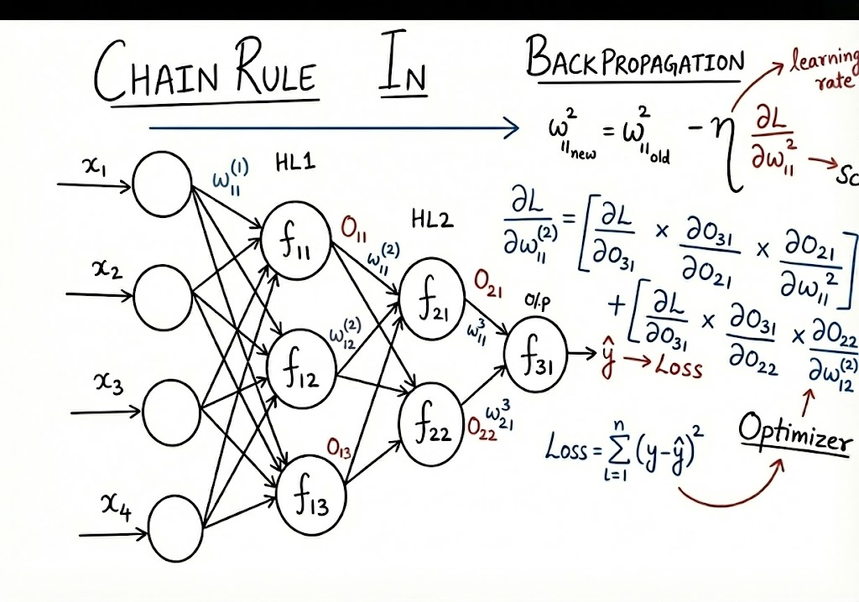

# **🧩 A Simple Neural Network Structure**

Krish Naik describes:

* Input layer: X1, X2, X3, X4
* Hidden Layer 1: 3 neurons
* Hidden Layer 2: 2 neurons
* Output Layer: 1 neuron → **ŷ (y-hat)**

Weights are named like:

* **W11¹** → weight for neuron1 of layer1
* **W11²** → weight for neuron1 of layer2

Outputs:

* O₁₁, O₁₂, O₁₃ → hidden layer 1
* O₂₁, O₂₂ → hidden layer 2
* O₃₁ → output (ŷ)

# **⚙️ Loss Function**

Commonly used loss function:

Loss = Σ (y - ŷ)²

Our goal: **minimize loss** by adjusting weights.

This is done using:

### **🔄 Backpropagation + Gradient Descent**

# **📉 Weight Update Formula**

Every weight is updated using:

**new_weight = old_weight − learning_rate × (∂Loss / ∂weight)**

Main challenge:  
 How to calculate **∂Loss / ∂weight** for deep networks?

👉 **Solution: Chain Rule**

# **🔗 What is Chain Rule?**

If a variable depends on another variable through multiple layers:

L → O3 → O2 → W

Then derivative is:

∂L/∂W = (∂L/∂O3) × (∂O3/∂O2) × (∂O2/∂W)

This multiplication of derivatives is the **chain rule**.

# **🎯 Simple Example of Chain Rule in NN (From Video)**

### **Example 1: Weight directly connected to output**

Weight: **W11³** → affects output O31 directly

∂L/∂W11³ = (∂L/∂O31) × (∂O31/∂W11³)

### **Example 2: Weight in earlier layer**

Weight: **W11²** → affects:  
 → O21 → O31 → Loss

So:

∂L/∂W11²

= (∂L/∂O31) × (∂O31/∂O21) × (∂O21/∂W11²) +

(∂L/∂O31) × (∂O31/∂O22) × (∂O22/∂W12²)

### **Example 3: When two paths lead to the output**

If a neuron splits into 2 paths:

**∂L/∂W = gradient_path1 + gradient_path2**

This is because both paths influence loss.

# **🛠 Practical Use Cases**

Backpropagation with chain rule is used in:

* Training image classifiers (CNNs)
* Training transformers (BERT, GPT)
* Speech recognition
* GAN training
* Recommendation systems
* Reinforcement learning

# **🎤 Interview Questions (with Answer Hints)**

### **1. What is the chain rule in backpropagation?**

Chain rule helps compute gradients of loss with respect to earlier layer weights by multiplying partial derivatives step-by-step backward.

### **2. Why do we need chain rule in deep learning?**

Because output depends on many nested functions (weights + activations), chain rule allows gradient to pass through layers.

### **3. What is gradient descent?**

An optimization method that updates weights by moving in the direction opposite to gradient to minimize the loss.

### **4. What is the formula for weight update?**

w_new = w_old − η × ∂L/∂w

### **5. What happens if learning rate is too high or too low?**

* Too high → unstable training, oscillation
* Too low → very slow learning

### **6. How does backpropagation handle multiple paths?**

Gradients from all paths are summed before updating weight.

# 

# 

# **📘 Lecture 10 : Vanishing Gradient Problem**

## **🎯 What is the Vanishing Gradient Problem?**

Vanishing Gradient =  
 👉 During backpropagation, gradients (slopes) become extremely small as they move backward through layers.  
 👉 When gradients become tiny, **weights stop updating**.  
 👉 As a result, the neural network **stops learning**, especially in early layers.

This problem was common in the 1980s–2000s because networks mainly used **sigmoid** (and tanh) activation functions.

# **🔍 Why Does Vanishing Gradient Happen?**

### **1️⃣ Because of the sigmoid activation function**

Sigmoid compresses any value into the range **0 to 1**:

σ(z) = 1 / (1 + e^(-z))

The derivative of sigmoid is:

σ'(z) = σ(z) × (1 − σ(z))

👉 **This derivative is always between 0 and 0.25**, no matter what z is.

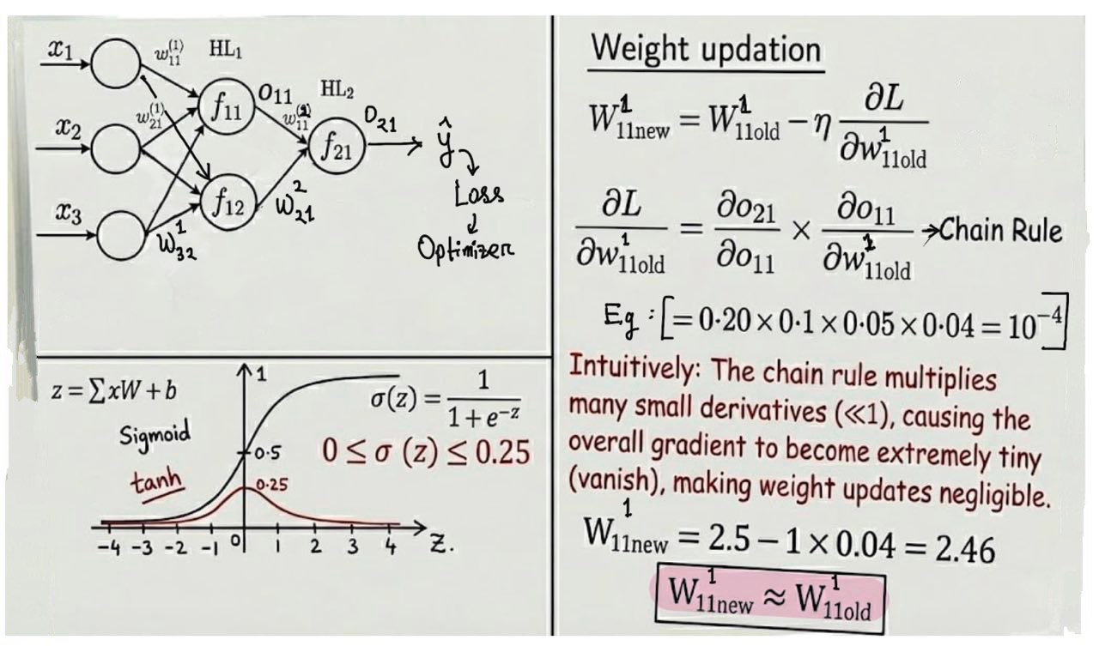

# **💡 Intuition**

👉 Imagine trying to push a car with *microscopic force*.  
 👉 No matter how many times you push, it **won't move**.

That’s exactly what happens to neural networks.

# **🔥 Why was deep learning not successful before 2000?**

Because:

* Sigmoid and tanh were dominant
* Gradients kept vanishing
* Networks deeper than 3–4 layers could NOT be trained
* ReLU wasn’t discovered yet

This is why deep learning exploded after **ReLU (2011)**.

# **🛠 Where You See Vanishing Gradient**

* Deep neural networks (ANNs)
* RNNs (Recurrent Neural Networks)
* LSTMs were invented to solve this!
* CNNs before ReLU
* Any deep model using sigmoid/tanh everywhere

# **🆚 Sigmoid vs Tanh vs ReLU**

| **Activation** | **Derivative Range** | **Vanishing Risk** |
| --- | --- | --- |
| Sigmoid | 0 to 0.25 | VERY HIGH |
| Tanh | 0 to 1 | High |
| ReLU | 0 or 1 | VERY LOW |

# **🎤 Interview Questions + Answers**

### **1. What is vanishing gradient?**

When gradients shrink exponentially as they propagate backward, causing very small weight updates and preventing learning.

### **2. Why does vanishing gradient occur in sigmoid?**

Because sigmoid derivative is always between 0 and 0.25, causing gradients to become very small when multiplied across layers.

### **3. Why were deep networks not used before 2000?**

Due to vanishing gradients caused by sigmoid/tanh activation functions.

### **4. How does ReLU solve vanishing gradient?**

ReLU has derivative 1 for positive values, so gradients do not shrink.

### **5. Name a model invented to solve vanishing gradient in RNNs.**

**LSTM (Long Short-Term Memory)**

# **📘 Lecture 11 : Exploding Gradient Problem – Beginner Friendly Notes**

## **What is Exploding Gradient?**

The exploding gradient problem happens when gradients become too large during backpropagation.

This causes:

* 🚨 very large updates to weights
* 🚨 unstable training
* 🚨 the loss jumps wildly
* 🚨 the model fails to converge (never learns properly)

Opposite of vanishing gradient, where gradients become too small.

# **Why Does Exploding Gradient Happen?**

Exploding gradients mainly happen because of very large weight values.

During backprop, we calculate:

∂L/∂W11 = (product of many derivatives in chain rule)

If one weight = 500

and another = 200

and another = 100

Then gradients become:

gradient ≈ 0.25 × 500 × 200 × 100

= 2,500,000 (VERY LARGE)

Even though sigmoid gives 0–0.25,

large weights multiply and enlarge the gradient → explosion.

# **What Happens When Gradient Explodes?**

Weight update formula:

W_new = W_old - lr × gradient

If gradient = 2,500,000

learning rate = 1

W_new = W_old - 2,500,000

👉 Weight changes too much

👉 Network jumps around

👉 Loss keeps increasing or oscillating

👉 Model never reaches minimum

Signs you see in training:

* Loss = NaN
* Loss becomes extremely large
* Weight values become huge
* Accuracy fluctuates heavily

# **Chain Rule Intuition**

Gradient for first-layer weight W11 is:

dL/dW11 = (dL/dO3) × (dO3/dO2) × (dO2/dO1) × (dO1/dW11)

Even if activations (sigmoid/tanh) → derivative small,

weights like 200, 300, 500 → cause the multiplication to explode.

# **Root Cause Summary**

| **Cause** | **Explanation** |
| --- | --- |
| 🚩 Large weight initialization | BIGGEST reason |
| 🚩 Deep networks (many layers) | More multiplication in chain rule |
| 🚩 High learning rate | Amplifies explosion further |
| 🚩 No normalization | Inputs accumulate large values |

# **How to Fix Exploding Gradients**

### **✔ 1. Weight Initialization Techniques**

Use:

* Xavier Initialization
* He Initialization

These set weights properly to avoid extremes.

### **✔ 2. Gradient Clipping**

Force gradient to stay within a safe range.

Example (PyTorch):

torch.nn.utils.clip_grad_norm_(model.parameters(), max_norm=1.0)

### **✔ 3. Lower Learning Rate**

Large learning rate × large gradient = instability.

### **✔ 4. Use ReLU-based Activations**

ReLU does not cause gradient explosion by itself.

### **✔ 5. Batch Normalization**

Keeps activations stable between layers.

# **Real-world Intuition**

### **Exploding Gradient is like this:**

Imagine you’re editing a photo:

* want brightness +5
* but you accidentally apply +500

The image becomes fully white — ruined.

Exploding gradients = weights become “too bright”.

# **🧪 Practical Example in Real ML Projects**

* RNNs suffer heavily from exploding gradients (before LSTM/GRU)
* Training deep CNNs without proper initialization
* Large learning rate in optimizers like SGD

# **Interview Questions + Answers**

### **1. What is exploding gradient problem?**

When gradients become extremely large during backpropagation, leading to unstable weight updates and failure to converge.

### **2. Why does exploding gradient occur?**

Mainly because of **large initial weights and deep chain-rule multiplications.**

### **3. How do you fix exploding gradients?**

Gradient clipping, good initialization (Xavier/He), reducing learning rate, batch normalization.

### **4. Difference between vanishing and exploding gradient?**

| **Vanishing** | **Exploding** |
| --- | --- |
| Gradients → very small | Gradients → very large |
| Learning becomes slow or stops | Learning becomes unstable |
| Common with sigmoid, tanh | Common with large weights |
| Causes shallow updates | Causes huge jumps |

### **5. In which architectures are exploding gradients common?**

Recurrent Neural Networks (RNNs) before LSTM/GRU.

# **📘 Lecture 12 : Dropout & Regularization**

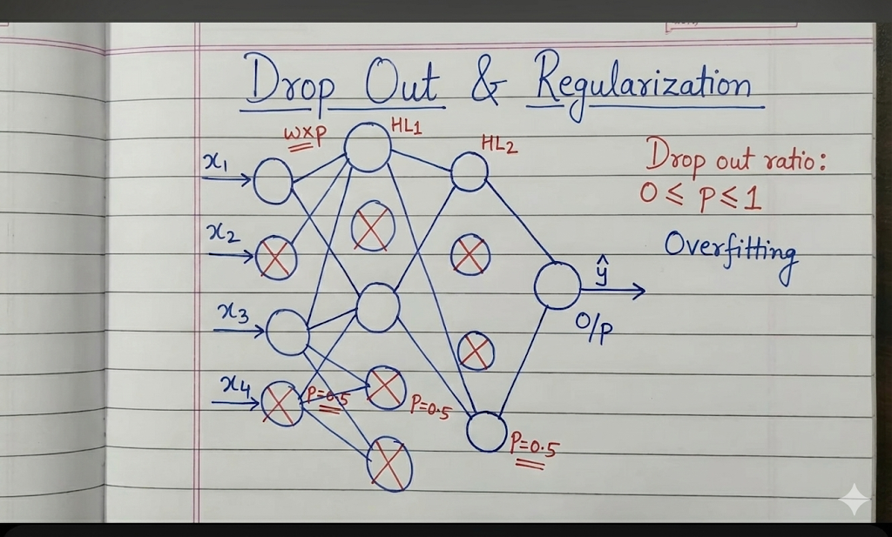

### **Why do we need regularization in deep neural networks?**

* Deep networks contain many weights and biases.
* With many parameters, the model tends to overfit the training data (high variance).
* Underfitting rarely happens in deep networks; overfitting is the real issue.

## **Ways to Reduce Overfitting**

1. Regularization (L1, L2)
2. Dropout (main topic of this lecture)

## **What is Dropout?**

* Introduced by Nitish Srivastava and Geoffrey Hinton (2014).
* Dropout is a technique where random neurons are deactivated (set to 0) during training.
* The percentage of neurons dropped is controlled by the dropout rate p (e.g., 0.5).

## **How Dropout Works (Training Phase)**

For each forward pass:

* In each layer, a subset of neurons is randomly “dropped” using probability p.
* Example: If p = 0.5, then half the neurons are turned off randomly.
* Only the active neurons participate in:
  + forward propagation
  + backpropagation
  + weight updates

This is similar to:

* Random Forests, where each tree uses a subset of features to reduce overfitting.

Dropout therefore:

* Prevents co-adaptation of neurons.
* Forces the network to learn more robust features.

## **How Dropout Works (Test / Inference Phase)**

* During testing, no neurons are dropped — everything is active.
* But since more neurons are now active than during training, the weights must be scaled.
* Each weight is multiplied by the dropout probability:  
   W_test = W_train × p

This ensures consistent output scales.

## **How to Choose Dropout Rate p**

* A typical value: 0.5 for hidden layers.
* Higher dropout rates can help when the model heavily overfits.
* To choose optimally:
  + Use hyperparameter tuning (grid search, random search, etc.).

## **Key Takeaways**

* Dropout is a type of regularization.
* It reduces overfitting by:
  + Randomly disabling neurons during training
  + Forcing the network to learn redundant, robust features
* During testing, all neurons work, but weights are scaled by p.

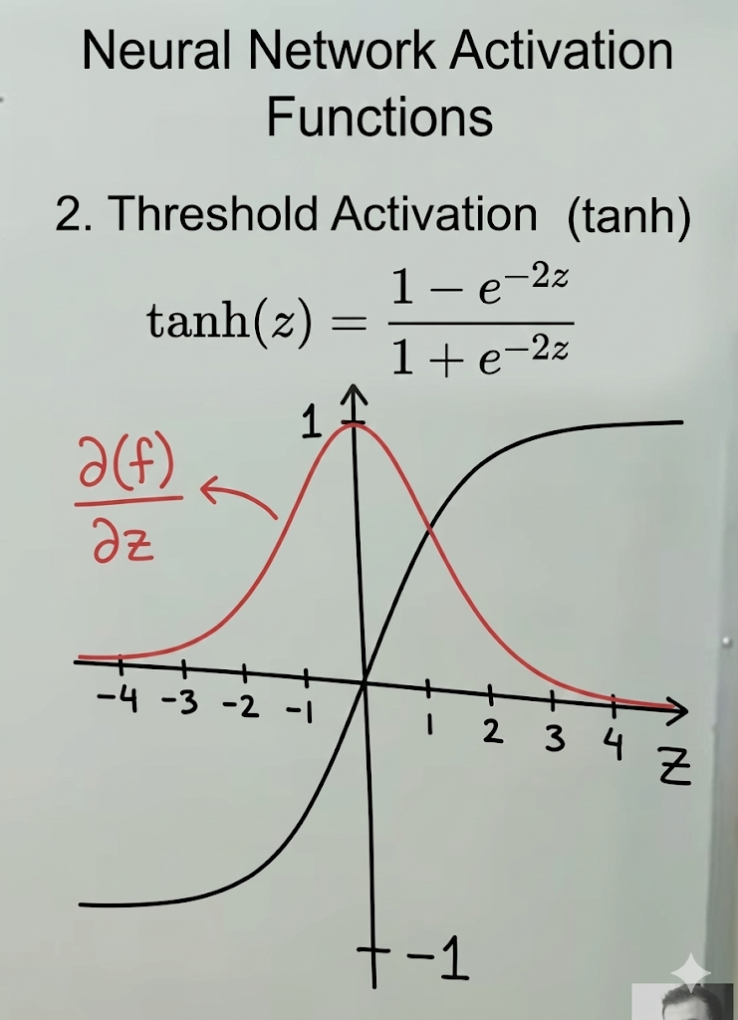

# **📘 Lecture 13 : ReLU, Vanishing Gradient & Leaky ReLU**

# **🔹 1. Recap: Why Sigmoid & Tanh Cause Vanishing Gradients**

### **Sigmoid**



* Output range: **0 to 1**
* Derivative range: **0 to 0.25**
* Very small derivative → when multiplied repeatedly during backprop, gradients shrink:  
  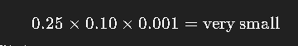
* Weight update becomes tiny →  
   **Wₙₑw ≈ Wₒₗd → slow learning or no learning**
* This is the **vanishing gradient problem**.

### **Tanh**

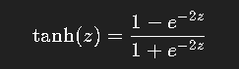

* Output range: **–1 to +1**
* Derivative range: **0 to 1**
* Still < 1 → repeated multiplication → **vanishing gradient**.

# **🔹 2. Introduction to ReLU**

### **ReLU formula**



### **How it behaves**

* If **z < 0**, output = **0**
* If **z > 0**, output = **z**

### **Derivative of ReLU**

* Positive side:  
   The line has a 45° slope → derivative = **1**
* Negative side:  
   Constant **0** → derivative = **0**

So:  
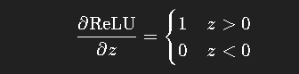

# **🔹 3. Why ReLU Solves the Vanishing Gradient Problem**

* Sigmoid derivatives < 0.25
* ReLU derivatives are either **0 or 1**
* When the derivative is 1 in positive region:  
  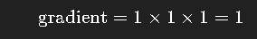
* During weight update:  
  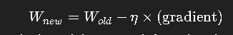
* A **meaningful change** happens in the weights → much faster learning.

Thus, **ReLU prevents gradients from shrinking** when z > 0.

# **🔹 4. The Downside of ReLU — Dead Neurons**

When z < 0:

* Output = 0
* Derivative = 0
* Gradient = 0
* No update occurs → neuron becomes permanently inactive

This is known as the **dead neuron problem**.

# **🔹 5. Fixing Dead Neurons: Leaky ReLU**

Leaky ReLU introduces a small slope on the negative side.

### **Leaky ReLU formula**



### **Derivative**

* For z > 0 → derivative = **1**
* For z < 0 → derivative = **0.01** (or any small α)

This prevents neuron death because the gradient never becomes zero.

# **🔹 6. Key Takeaways**

* **Sigmoid and tanh saturate → vanishing gradient problem**
* **ReLU** avoids saturation by having derivative **1** for positive values
* **ReLU is simple, fast, and widely used**
* **Leaky ReLU** solves ReLU's dead neuron issue by allowing a small negative slope
* Modern neural networks often use:
  + ReLU
  + Leaky ReLU
  + Parametric ReLU (PReLU)
  + ELU, GELU (more advanced)

# **📘 Lecture 14 — Deep Learning Activation Functions**

In this lecture, we explore **all major activation functions** used in deep learning—including many **ReLU variants**, **Swish**, **Softplus**, and **Softmax**—along with their intuition, mathematical behavior, advantages, and disadvantages.

# **🔶 1. Sigmoid Activation**

**Formula:**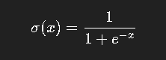

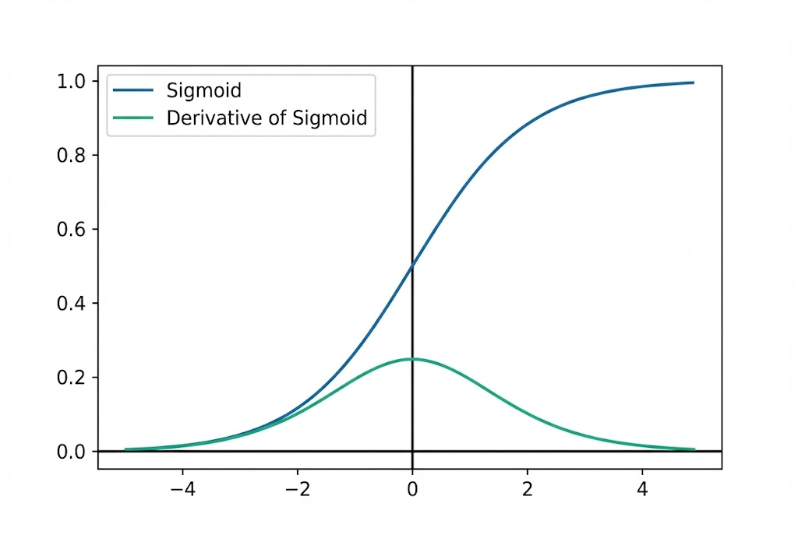

### **✔ Outputs**

* Range: **0 to 1**

### **✔ Notes**

* Useful for **binary classification** (final layer)
* **Derivative range:** 0 to 0.25 → causes **vanishing gradient**
* **Not zero-centered** → slows convergence
* **Prone to vanishing gradient** → very small updates during backprop

# **🔶 2. Tanh Activation**

**Formula:**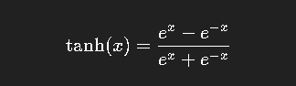

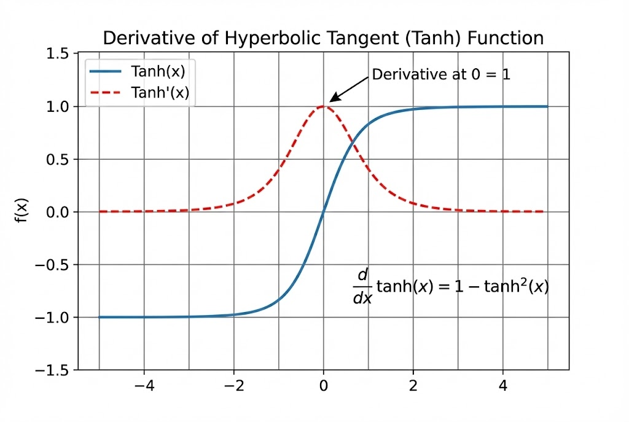

### **✔ Outputs**

* Range: **–1 to +1**

### **✔ Notes**

* **KZero-centered** → faster learning vs sigmoid
* Still suffers from **vanishing gradients**
* Derivative ∈ (0, 1)

# **🔶 3. ReLU (Rectified Linear Unit)**

**Formula:**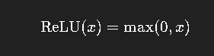

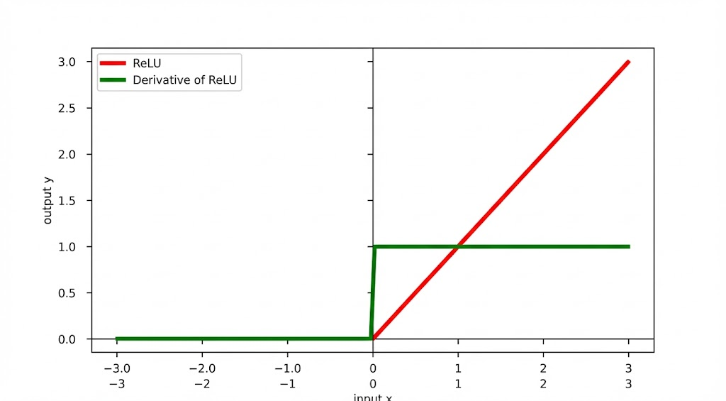

### **✔ Advantages**

* Very fast computation
* Solves **vanishing gradient problem**
* Derivative = 1 for x>0

### **❌ Problem — Dying ReLU**

* For x ≤ 0 → derivative = 0
* Neurons stop learning permanently

# **🔶 4. Leaky ReLU**

**Formula:** 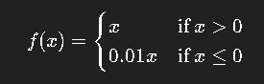

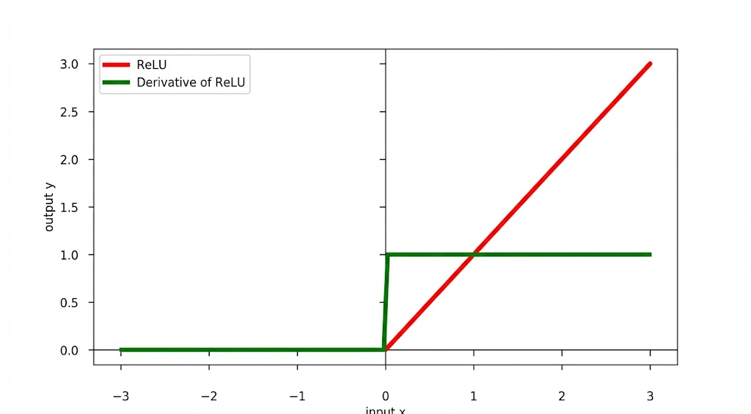

### **✔ Advantages**

* Prevents dying ReLU (gradient is **0.01** instead of 0)

### **❌ Issues**

* Still may lead to **vanishing gradient** when many weights are negative

# **🔶 5. ELU (Exponential Linear Unit)**

**Formula:**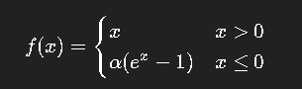

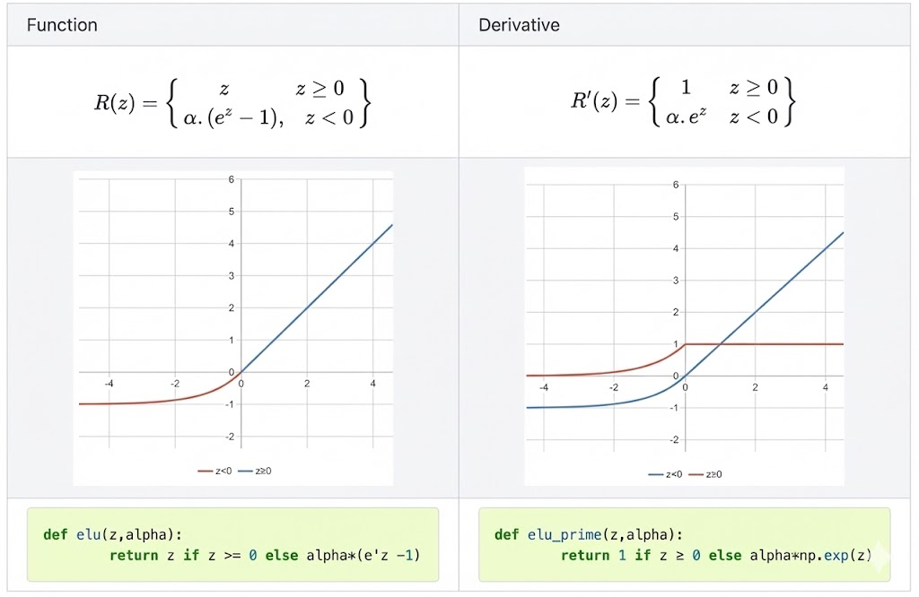

### **✔ Advantages**

* No dying ReLU
* Output becomes **zero-centered**
* Smooth curve in negative region
* Better convergence

### **❌ Disadvantage**

* **Computationally expensive** (exponential term)

# **🔶 6. PReLU (Parametric ReLU)**

**Formula:**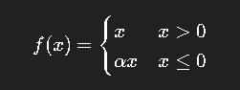

Where **α is learned during training**.

(image similar like Relu)

### **✔ Covers:**

* α = 0 → **ReLU**
* α = 0.01 → **Leaky ReLU**
* α learned → **PReLU**

### **✔ Advantage**

* Learns the best negative slope automatically

# **🔶 7. Swish (Self-Gated Activation — from Google Brain)**

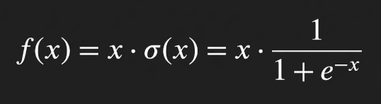

### **✔ Properties**

* Smooth, non-monotonic
* Works **best in very deep networks (40+ layers)**
* Prevents dying ReLU
* Zero-centered-ish
* Used in LSTM/Highway networks (self-gating)

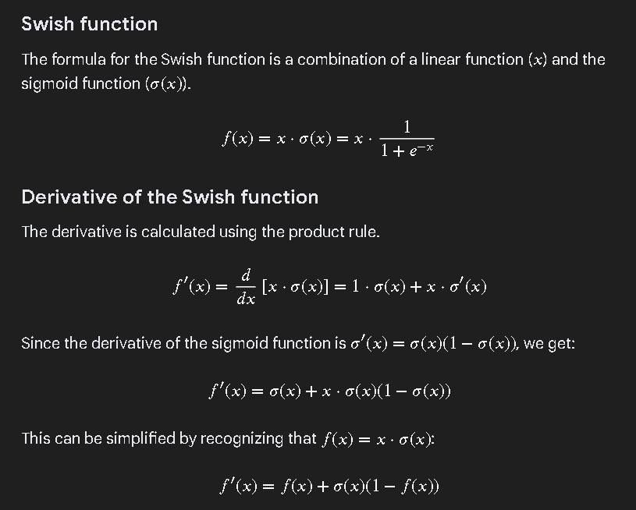

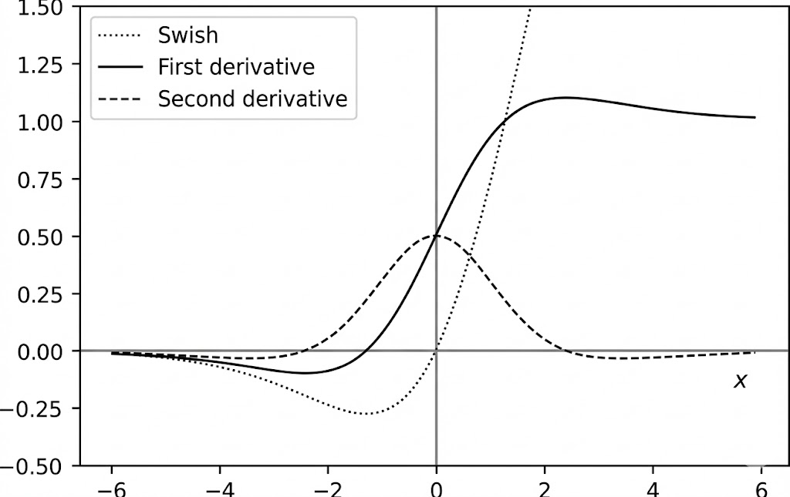

# **🔶 8. Softplus Activation**

**Smooth alternative to ReLU**

**Formula:**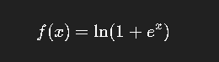

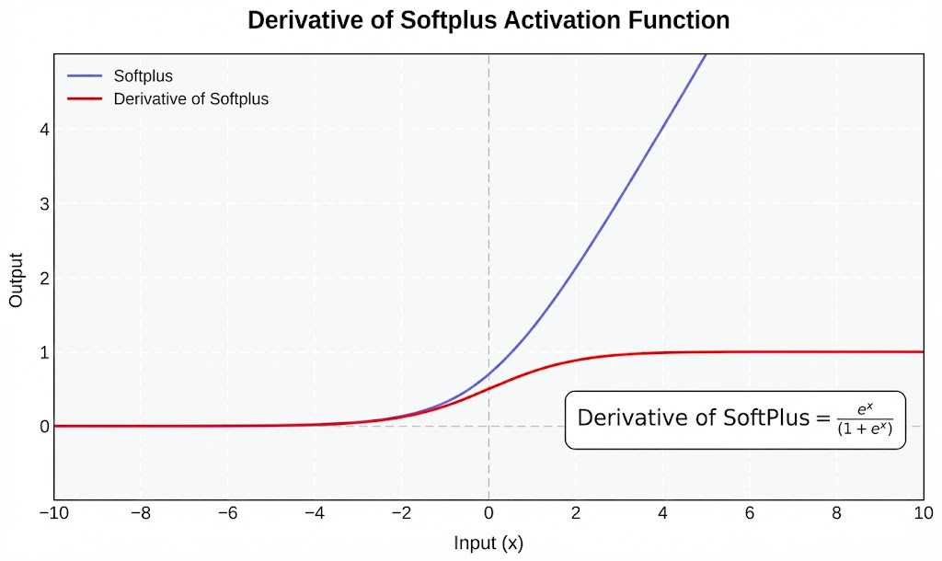

### **✔ Advantages**

* Derivative never exactly zero → avoids dying ReLU
* Smooth curve everywhere
* Ideal when **x=0** occurs in real cases

### **❌ Disadvantage**

* More computational cost (log + exponential)

# **🔶 9. Softmax Activation (Multiclass Classification)**

Used in **final layer** when output classes > 2.

### **✔ Formula**

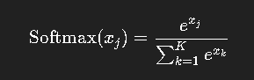

### **✔ Properties**

* Converts logits into **probabilities**
* All outputs sum to **1**
* Choose class with highest probability
* Used in classification tasks like **Dog/Cat/Monkey/Human**, etc.

# **🧠 Summary Table**

| **Activation** | **Zero-Centered** | **Vanishing Grad?** | **Dead Neurons?** | **Notes** |
| --- | --- | --- | --- | --- |
| Sigmoid | ❌ | ✔ | ❌ | Binary output |
| Tanh | ✔ | ✔ | ❌ | Better than Sigmoid |
| ReLU | ❌ | ❌ | ✔ | Fastest, but dying neurons |
| Leaky ReLU | ❌ | ⚠ | ❌ | Tiny negative slope |
| PReLU | ❌/✔ | ✔ | ❌ | Learns best slope |
| ELU | ✔Approximately | ❌ | ❌ | Smooth & zero-centered |
| Swish | ✔Approximately (not perfectly symmetric) | ❌ | ❌ | Best for deep (40+) networks |
| Softplus | ❌ | ❌ | ❌ | Smooth ReLU |
| Softmax | — | — | — | Multiclass output layer |

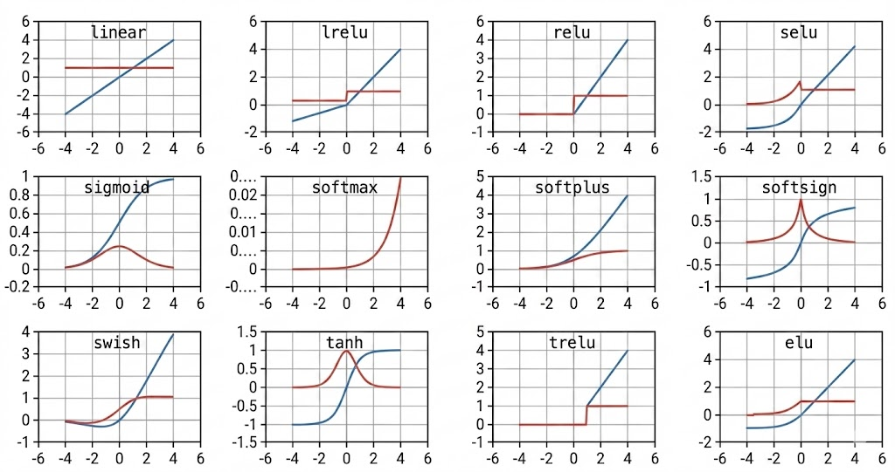

# **✅ Use of zero-centered features?**

### **Zero-centered features means:**

Your data is adjusted so that the **average (mean) becomes 0**.  
 For example, values are distributed around 0, with both **positive and negative** values.

# **🌟 Why is zero-centering useful?**

## **1. Speeds up training**

When features are centered around zero, the model **updates weights faster**.  
 This happens because the gradients in backprop become more balanced, making optimization easier.

👉 If data is not centered (all positive or all negative), gradients move in **one direction only**, slowing convergence.

## **2. Helps gradient descent reach the minimum quickly**

Zero-centered data ensures that the weight updates don’t “zig-zag” or take long curved paths.

👉 With zero-centered inputs, gradient descent moves **straight toward the minimum**, rather than taking a long detour.

## **3. Prevents bias in activation functions**

Some activation functions (like **sigmoid**, **ReLU**) work better when inputs are balanced around zero.

* If inputs are only positive → neuron always produces positive output
* If inputs are only negative → neuron may die or saturate

Zero-centered data keeps neuron outputs **in their active, useful range**, improving learning.

## **4. Makes weight updates symmetrical**

When inputs are centered at zero:

* Half the inputs push weights **up**
* Half push weights **down**

This creates **healthy, stable learning** for each neuron.

# **🧠 Simple example:**

Imagine a neuron receives only **positive values** (like 10, 20, 15).  
 Then the neuron’s output is always positive → gradient becomes unbalanced → learning slows.

But if values are like –2, 0, +2 (zero-centered),  
 the neuron can explore **both sides** of the activation curve → learns better.

# **🎯 In one sentence:**

### **Zero-centered features help neural networks learn faster, more accurately, and more smoothly by keeping gradients balanced and avoiding bias in activations.**

# **✅ Criteria for an activation function to be considered zero-centric**

### **1. The function must output both positive AND negative values**

A function is zero-centric only if its **range includes both sides of zero**.

Examples:  
 ✔ tanh → outputs (−1, 1)  
 ✔ ELU → outputs negative values for x < 0  
 ✔ Softsign → symmetric around zero

Non-example:  
 ✘ ReLU → outputs only ≥ 0  
 ✘ Sigmoid → outputs only (0, 1)

### **2. The function's output distribution should have mean ≈ 0**

If you feed inputs that are centered around zero (e.g., from BatchNorm or standardized data), the **expected value of the activation** should also be close to zero.

This prevents bias accumulation and ensures balanced gradients.

### **3. The function should be symmetric or approximately symmetric around 0**

Zero-centric functions tend to have:

* ( f(-x) \approx -f(x) ) (odd symmetry)  
   Example: tanh, softsign
* OR at least negative and positive regions that balance  
   Example: ELU, Swish (not perfectly symmetric but zero-centered enough)

### **4. The derivative should not be one-sided**

For stable gradient flow, the derivative should also:

* produce both positive and negative values indirectly
* avoid one-sided gradients (common in ReLU)

This helps maintain healthy gradient dynamics during backprop.

### **5. The function should avoid output saturation around non-zero constants**

Zero-centric activations should **not** saturate at large positive values that shift output mean permanently.

For example:

* Sigmoid saturates near 1 → NOT zero-centric
* Tanh saturates at ±1 → still symmetric → zero-centric

Symmetry is key.

# **✔ Summary of the conditions for selecting a zero-centric activation**

An activation is chosen as *zero-centered* if it satisfies:

### **(1) Produces both positive and negative outputs**

### **(2) Has an expected output near zero for zero-mean inputs**

### **(3) Has symmetry or approximate symmetry around zero**

### **(4) Supports balanced gradient flow (not one-sided gradients)**

### **(5) Avoids skewing neuron activations toward positive-only regions**

If a function satisfies these conditions, it is considered (and chosen as) **zero-centric**.

# **📘 Lecture 15 : WEIGHT INITIALIZATION**

# **⭐ 1. Why Weight Initialization Matters**

During forward and backward propagation:

### **Bad Initialization Causes:**

* **Vanishing gradients:** weights become too small → no learning
* **Exploding gradients:** weights grow too large → unstable training
* **Symmetry problem:** neurons behave identically → no feature learning

### **Goal of weight initialization:**

* Keep activation values & gradients at a stable scale as they pass through each layer.

# **🔵 2. Zero Initialization (❌ BAD — Never Use)**

**Definition:**All weights are initialized to **0**.

### **Why it's bad:**

* Every neuron receives the same gradient.
* All neurons learn **the same features**.
* Network fails to break symmetry.

### **Only exception:**

* Biases can be initialized to zero, **not weights**.

# **🟡 3. Random Initialization (Basic Uniform/Normal)**

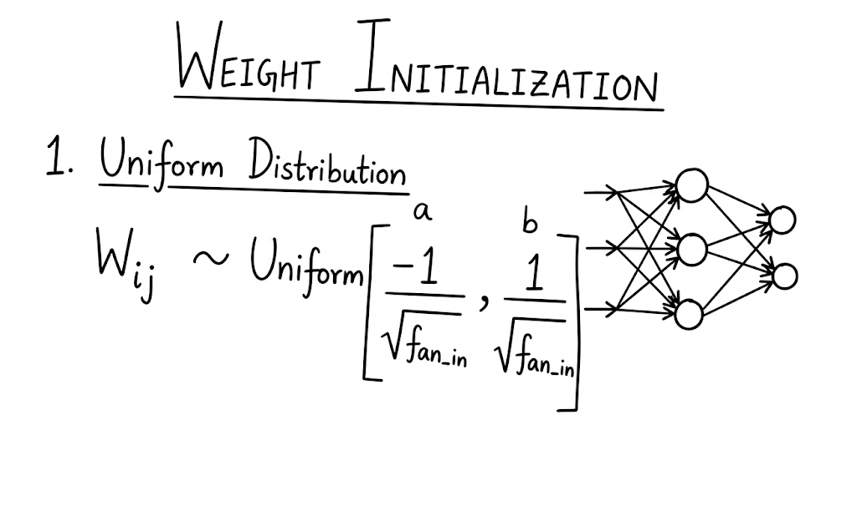

Weights are set to small random values:

Example:

W = np.random.randn() * 0.01

### **Pros:**

* Breaks symmetry
* Works for small networks

### **Cons:**

* For deep networks, signals shrink or grow across layers →  
  **still risks vanishing or exploding gradients**.

# **🟢 4. Xavier / Glorot Initialization**

Best for **Sigmoid** or **Tanh** activation functions.

The idea: **Keep the variance of activations the same** from input to output.

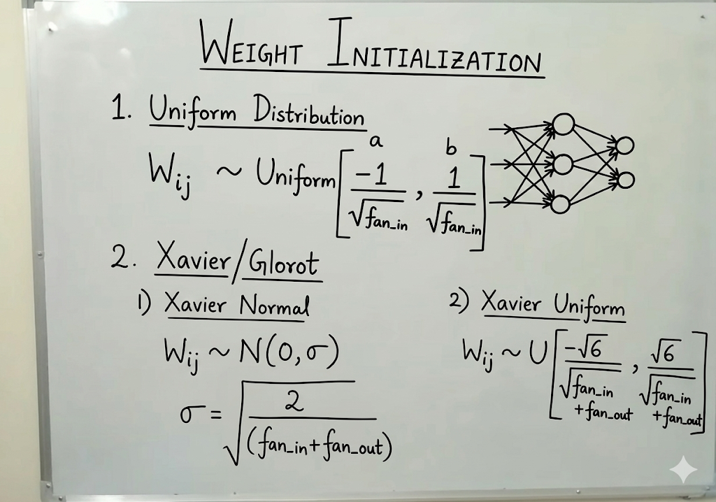

## **✔ 4.1 Xavier Normal Initialization**

[  
W_{ij} \sim N\left(0,\ \sigma^2\right)  
]

[  
\sigma = \sqrt{\frac{2}{\text{fan_in}+\text{fan_out}}}  
]

## **✔ 4.2 Xavier Uniform Initialization**

[  
W_{ij} \sim U\left(-\sqrt{\frac{6}{\text{fan_in}+\text{fan_out}}},\ \sqrt{\frac{6}{\text{fan_in}+\text{fan_out}}}\right)  
]

### **Why Xavier works:**

* Prevents activations from shrinking or blowing up
* Perfect for tanh/sigmoid because they have **bounded** activation ranges
* Good for balanced gradients across layers

# **🔴 5. He Initialization (Kaiming Initialization)**

Best for **ReLU and ReLU variants** (Leaky ReLU, ELU, GELU).

ReLU zeros out half of the input values → variance changes.  
He initialization corrects this.

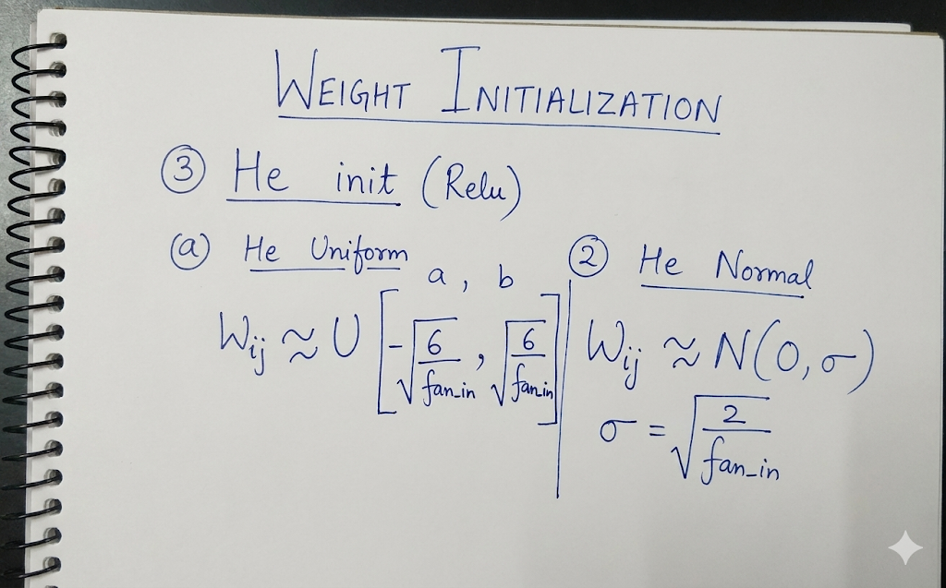

## **✔ 5.1 He Normal Initialization**

[  
W_{ij} \sim N\left(0,\ \sigma^2\right)  
]

[  
\sigma = \sqrt{\frac{2}{\text{fan_in}}}  
]

## **✔ 5.2 He Uniform Initialization**

[  
W_{ij} \sim U\left(-\sqrt{\frac{6}{\text{fan_in}}},\ \sqrt{\frac{6}{\text{fan_in}}}\right)  
]

### **Why He works well:**

* Adjusts for the "half-cut" effect of ReLU
* Keeps gradient variance stable
* Standard choice for deep CNNs and large models

# **📌 6. Quick Comparison Table**

| **Initialization** | **Activations** | **Formula Basis** | **Good?** | **Notes** |
| --- | --- | --- | --- | --- |
| **Zero** | None | 0 everywhere | ❌ No | Causes symmetry; no learning |
| **Random** | Any | Small random | ⚠️ Limited | Can cause gradient issues |
| **Xavier (Normal/Uniform)** | Tanh, Sigmoid | fan_in + fan_out | ✅ Excellent | Avoids vanishing gradients |
| **He (Normal/Uniform)** | ReLU family | fan_in | ⭐ Best | Industry standard for deep nets |

# **⭐ Lecture 16 — Stochastic Gradient Descent (SGD): A Clear Explanation**

## **1. Recap: Gradient Descent (GD)**

Gradient Descent is an optimization algorithm used to minimize the loss function in machine learning and deep learning.

### **Weight Update Formula**

W_{\text{new}} = W_{\text{old}} - \eta \cdot \frac{\partial L}{\partial W}

Where:

* W = weights
* \eta = learning rate
* \frac{\partial L}{\partial W} = gradient of loss with respect to weight

### **How Gradient Descent Works**

* Think of the loss function as a curved bowl.
* Your goal is to reach the lowest point → the global minimum.
* At every step, you compute the slope (gradient).  
  + Positive slope → decrease weight
  + Negative slope → increase weight
* In standard Gradient Descent, you use all N data points in your dataset to compute the gradient.

### **Formula for Loss Using All Data Points**

\text{Loss} = \sum_{i=1}^{N} (y_i - \hat{y}_i)^2

### **Disadvantages of Full-Batch GD**

* Very slow for large datasets (e.g., 1 million records).
* Requires a lot of memory to load all data at once.
* Less practical for modern deep learning.

# **⭐ 2. Stochastic Gradient Descent (SGD)**

### **What is SGD?**

In SGD, we update the weights using only ONE data point at a time.

At every step:

1. Pick one training example
2. Perform forward pass to compute \hat{y}
3. Calculate loss
4. Update weights

### **Loss Formula for One Data Point**

\text{Loss} = (y - \hat{y})^2

### **Why is it called “Stochastic”?**

* Because we use random (stochastic) data points each time.
* Updates are faster but noisy—the path towards the minimum is zig-zag.

# **⭐ 3. Mini-Batch SGD (Most Common Technique)**

Mini-Batch SGD is a combination of GD and SGD.

### **How it works**

* Choose a batch size K (e.g., 32, 64, 128).
* Instead of using 1 point (SGD) or all points (GD), use a small group of K data points.

### **Loss Function for Mini-Batch**

\text{Loss} = \sum_{i=1}^{K} (y_i - \hat{y}_i)^2

Where:

* K < N

### **Advantages of Mini-Batch SGD**

✔ Faster than GD

✔ Less noisy than SGD

✔ Works best with GPUs

✔ Most commonly used in neural networks (ANN, CNN, RNN, etc.)

# **⭐ 4. Visualizing Convergence**

### **Gradient Descent**

* Smooth path
* Moves directly toward the global minimum
* Because gradient is computed using the entire dataset

### **Stochastic / Mini-Batch Gradient Descent**

* Path looks like a zig-zag
* Noisy updates because gradient is computed using fewer samples
* Eventually reaches the minimum but less smoothly

### **Important Insight**

\nabla L_{\text{Mini-Batch}} \approx \nabla L_{\text{Gradient Descent}}

Meaning mini-batch gradient is an approximation of full gradient.

# **⭐ 5. Why We Prefer Mini-Batch SGD Today**

| **Method** | **Data Used** | **Speed** | **RAM Usage** | **Noise** | **Suitable For** |
| --- | --- | --- | --- | --- | --- |
| Gradient Descent | All N | Slow | High | Low | Very small datasets |
| SGD | 1 sample | Fast | Very Low | High | Online learning |
| Mini-Batch SGD | K samples | Fast | Low | Medium | Deep learning (ANN, CNN, etc.) |

Mini-batch SGD is the default in neural networks.

# **⭐ 6. Problem with SGD: Noise**

The noise comes from:

* Using only 1 or a few samples
* Producing fluctuating gradients
* Resulting in zig-zag movement

This noise is sometimes helpful (escapes local minima), but usually undesirable.

# **⭐ 7. Solution: SGD with Momentum**

(This will be covered in the next lecture)

Momentum reduces noise by:

* Accumulating past gradients
* Stabilizing the path
* Faster convergence

Below is a clean, structured, student-friendly explanation and notes on all the topics you listed. These are written as if you’re preparing for an exam or building solid conceptual understanding.

# **📘 Lecture 17 : Global Minima, Local Minima**

# **1. Cost Function (Loss Function)**

### **What it is**

A Cost Function measures how well or poorly a machine learning model is performing.

It quantifies the error between:

* Actual value (y)
* Predicted value (ŷ)

### **Why it matters**

The goal of training a model is to find parameter values (weights, bias) that minimize this error.

### **Examples**

* Mean Squared Error (Regression)
* Cross-Entropy (Classification)

### **Visual Understanding**

Imagine a curved surface / bowl.

* X-axis = model parameters
* Y-axis = cost

Your job is to move to the lowest point on this surface.

# **2. What are Minima?**

### **Definition**

Minima are points where the cost function takes the lowest value in a region.

There are two types:

1. Global Minimum
2. Local Minimum

# **3. Global Minimum**

### **Definition**

The absolute lowest point of the entire cost function graph.

At this position:

* The error is minimum.
* Model parameters are best optimized.

### **Convex Functions**

* These look like a smooth U-shaped bowl.
* Only one minimum exists → the global minimum.
* Gradient Descent can easily reach this point.

### **Example**

Linear regression with a simple MSE loss → perfectly convex.

# **4. Local Minimum**

### **Definition**

A minimum that is lower than nearby points but not the lowest point overall.

### **Non-convex Functions**

Deep learning models often use non-linear activation functions → creates a complex cost surface with:

* Multiple hills
* Multiple valleys

→ Local minima act like traps.

### **What happens?**

* Gradient = 0 at local minima
* Gradient Descent stops updating, thinking it has reached the lowest point
* But the model is still not optimal  
    
   → Leads to suboptimal accuracy or poor generalization

# **5. Why Local Minima are a Problem?**

### **Intuition**

Imagine walking down a mountain in the dark with a flashlight:

* You may reach a small valley and think it’s the lowest point.
* But a much deeper valley exists elsewhere.

The small valley = Local Minimum

The lowest valley = Global Minimum

### **In ML Training**

The optimizer might:

* Get stuck early
* Fail to reach the best parameters
* Produce lower model performance

# **6. How Do We Avoid or Escape Local Minima?**

Modern training uses clever optimization methods:

### **1. Momentum**

* Remembers the previous direction
* Helps roll over small bumps

### **2. RMSProp**

* Adjusts learning rate per parameter
* Avoids oscillations

### **3. Adam (Momentum + RMSProp)**

* Most commonly used
* Automatically adapts learning rate
* Great at escaping local minima

### **4. Activation Functions**

* ReLU helps avoid plateaus (flat regions)
* Sigmoid/tanh are more prone to vanishing gradients → harder to escape minima

# **7. Key Takeaways**

| **Concept** | **Meaning** |
| --- | --- |
| Cost Function | Measures how wrong the model is |
| Goal | Minimize this cost |
| Global Minimum | Best possible point (lowest error) |
| Local Minimum | Trap that stops optimization early |
| Convex function | Only one minimum → easier to train |
| Non-convex function | Multiple minima → deep learning challenges |
| Optimizers like Adam | Help escape local minima |

# **📘 Lecture 18 : SGD with Momentum**

# **1. The Core Problem with Simple Gradient Descent**

In many ML problems (especially deep networks), the loss landscape is not symmetrical:

* One direction may be steep
* Another direction may be flat
* These form ravines, valleys, or banana-shaped contours (common in RNNs, CNN layers, logistic regression on scaled data)

### **What happens without momentum:**

* The gradient in the steep direction has large magnitude → big jumps
* The gradient in the shallow direction has small magnitude → tiny progress
* Result = zig-zagging across the valley while inching toward the minimum
* The path is slow, unstable, and wasteful

This is why simple SGD converges slowly on ill-conditioned problems (where gradient magnitudes differ drastically by direction).

# **2. The Physical Intuition Behind Momentum**

SGD = like a person walking downhill who instantly changes direction at every tiny slope change.

Momentum = like a heavy ball rolling down a valley:

* It accumulates speed in directions that are consistent
* Small bumps or opposing gradients don’t immediately change its direction
* The ball builds inertia in direction of the minimum

This makes the optimization:

* More stable
* More directional
* Faster in the long run
* Less sensitive to noisy gradients (especially in mini-batch SGD)

# **3. The Real Reason Momentum Works (Conceptual)**

Momentum is a form of low-pass filtering applied to gradients.

* High-frequency noise (zig-zag) gets suppressed
* Low-frequency consistent direction gets boosted

In other words:

Momentum amplifies useful signals and damps noise.

This interpretation is extremely important in deep learning:

* training is noisy
* gradients vary across batches
* momentum smooths out this randomness  
  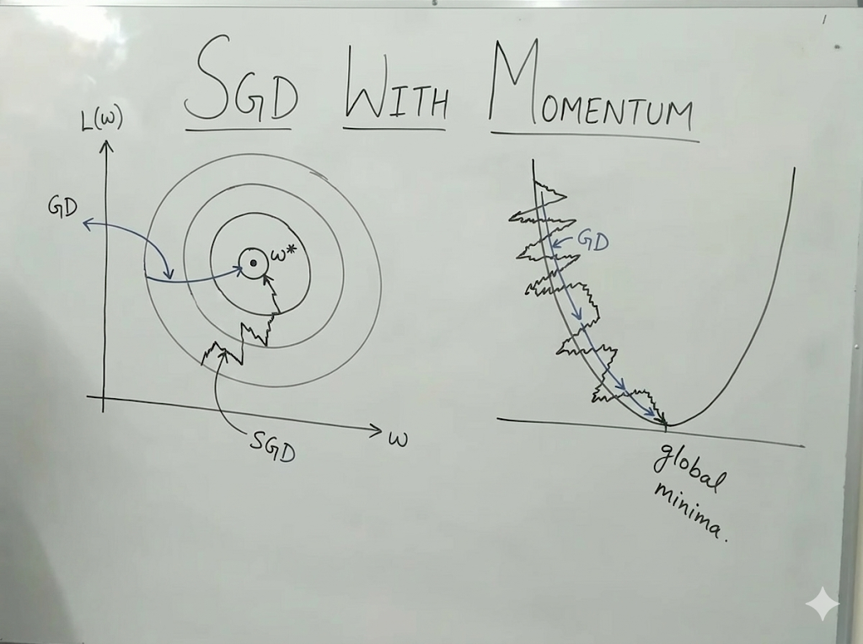

# **4. Mathematical View: Velocity as an Exponential Smoother**

Momentum uses a velocity term V_t:

V_t = \gamma V_{t-1} + (1-\gamma) \nabla L_t

Some frameworks use

V_t = \gamma V_{t-1} + \eta \nabla L_t

Either way, the key is the term:

* \gamma \approx 0.9
* meaning we keep 90% of last step’s direction
* and add 10% of the current gradient influence  
  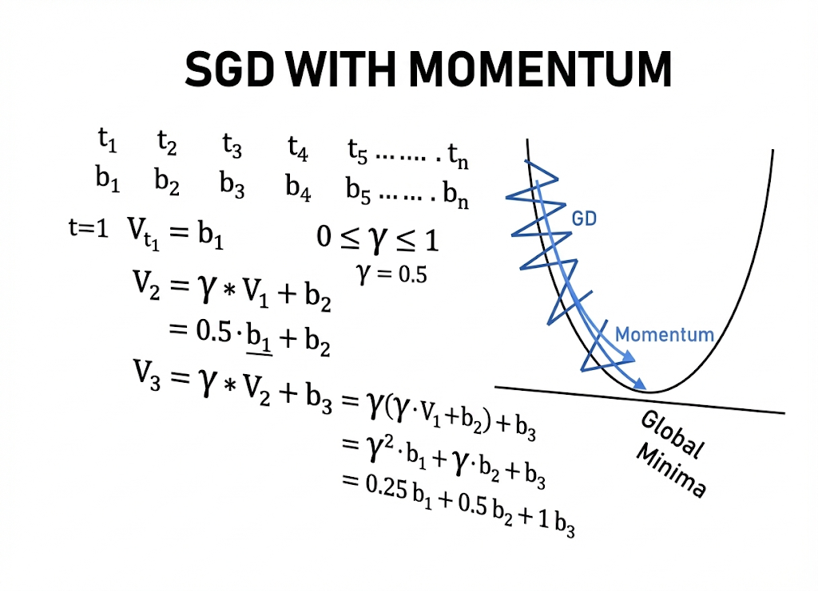

### **Why this works mathematically:**

If you expand recursively:

V_t = \gamma^{t-1} b_1 + \gamma^{t-2} b_2 + \dots + \gamma b_{t-1} + b_t

This is an Exponentially Weighted Moving Average (EWMA).

Properties:

* Recency bias: newest gradients matter most
* Exponential decay: old gradients never disappear entirely
* Noise cancellation: alternating signs diminish each other  
  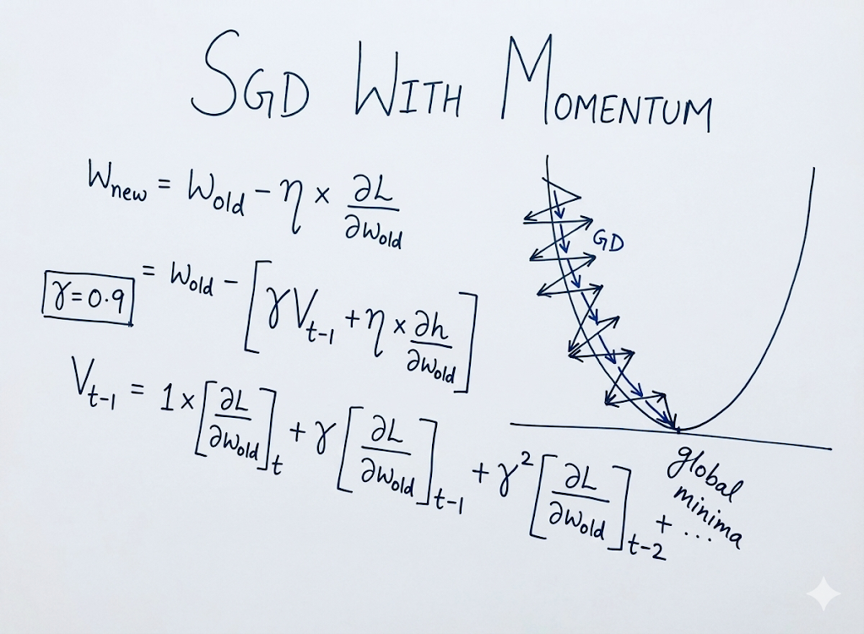

# **5. Geometric Interpretation**

On a contour plot:

### **Without Momentum**

* You oscillate perpendicular to the valley
* The optimizer wastes steps correcting the overshoots
* Movement toward the minima is extremely slow

### **With Momentum**

* Perpendicular oscillations cancel due to averaging
* Parallel motion (toward the minimum) accumulates
* Path becomes smooth, curved, and faster
* Looks like a ball gliding directly down the center

Momentum turns a jagged path into a direct accelerating trajectory.

# **6. Important Practical Insights**

### **Why momentum is usually set to**

### **0.9**

* Empirically found very stable
* Good balance between smoothing and responsiveness
* Used in classical networks (AlexNet, VGG, early ResNets)

### **What happens if γ is too small:**

* Noisy updates
* No real “memory”
* Almost same as SGD

### **What happens if γ is too large:**

* Overshooting
* Oscillation
* Divergence

### **Mini-batch training NEEDS momentum**

Because small batches give noisy gradients, momentum reduces variance and improves learning stability.

# **Summary Table for Memory**

| **Concept** | **Explanation** |
| --- | --- |
| What problem momentum solves | Zig-zag, slow convergence, noisy gradients |
| Why it works | Exponential smoothing + inertia |
| Formula | V_t = \gamma V_{t-1} + \eta \nabla L_t |
| Weighting | Recent gradients matter more |
| Visual effect | Smooth, directional path |
| Typical γ | 0.9 |
| Benefit | Faster convergence, stability, reduced noise |

# **📘 Lecture 19 : Adagrad Optimizer (Adaptive Gradient Algorithm)**

## **1. Why We Need Adagrad**

Before Adagrad, optimizers like **Gradient Descent**, **Stochastic Gradient Descent (SGD)**, and **Mini-batch SGD** used a **constant learning rate** (η).  
 This creates problems:

* If η is **too large** → the model overshoots minima.
* If η is **too small** → learning becomes very slow.
* One constant learning rate cannot adapt to the behavior of different parameters.

**Adagrad solves this by giving each parameter its own learning rate that changes over time.**

## **2. Weight Update Equation**

Adagrad modifies the standard gradient descent update:

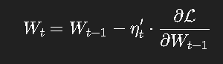

### **Components:**

* **W_t** – Updated weight at step *t*
* **W_{t-1}** – Previous weight
* **∂L/∂W** – Gradient of loss wrt weight
* **η′ₜ** – Adaptive learning rate (Adagrad’s key innovation)

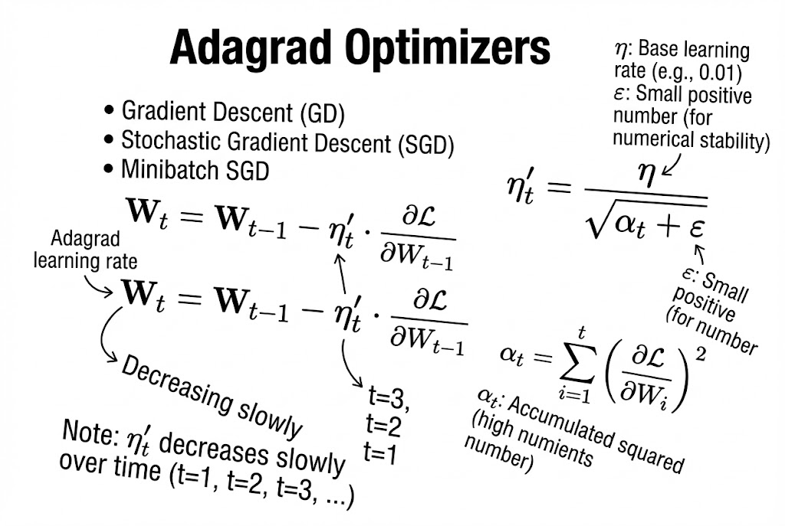

## **3. Adagrad’s Adaptive Learning Rate**

The learning rate changes each step:

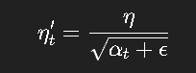

### **Terms:**

* **η (eta)** – Base learning rate (user-defined, e.g., 0.01)
* **ε (epsilon)** – Tiny constant to avoid division by zero (e.g., 1e−8)
* **α_t** – Accumulated squared gradients up to step t

## **4. What is ( \alpha_t )?**

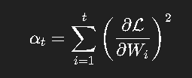

### **Meaning:**

* At every iteration:
  1. Compute gradient
  2. Square it
  3. Add it to previous total
* Therefore **αₜ always increases** (because it is a sum of squared values).

## **5. Why the Learning Rate Decreases**

As training goes on:

* αₜ increases
* denominator √(αₜ + ε) increases
* η′ₜ = η / (something large) → **decreases**

So:  
 👉 **The learning rate becomes smaller over time.** 👉 The model takes **smaller and safer steps** as it learns more.

## **6. Behavior of Adagrad**

### **A. Useful Behavior**

* For parameters with **frequent and large gradients**, αₜ grows fast → learning rate decreases → prevents overshooting.
* For parameters with **small or rare gradients**, αₜ grows slowly → learning rate remains relatively high → helps learning.

This makes Adagrad suitable for:

* Sparse data
* NLP
* Recommender systems
* Text classification

### **B. Limitation**

Over a long time:

* αₜ becomes very large
* √αₜ becomes huge
* η′ₜ becomes extremely small
* **Weights stop updating → training stalls**

This is the biggest problem with Adagrad.

➡️ Later optimizers like **RMSprop and Adam** were created to fix this exact issue.

# **7. Summary Table**

| **Concept** | **Explanation** |
| --- | --- |
| Problem in GD | Constant learning rate causes slow or unstable convergence |
| Main Idea of Adagrad | Each parameter gets its own adaptive learning rate |
| αₜ | Sum of all past squared gradients |
| Learning Rate Formula | ( \eta'_t = \frac{\eta}{\sqrt{\alpha_t + \epsilon}} ) |
| Behavior | Learning rate shrinks over time |
| Advantage | Good for sparse features |
| Disadvantage | Learning rate eventually becomes too small |

# **📘 Lecture 20 :** Lectu Adadelta & RMSprop Optimizers

### **1. Context: The Problem with Adagrad**

In the previous lecture, we discussed **Adagrad** (Adaptive Gradient Optimizer). Its main feature is using different learning rates for each weight/parameter at every iteration. However, Adagrad has a significant disadvantage that Adadelta and RMSprop aim to solve.

**The Flaw in Adagrad:**

* In Adagrad, the adaptive learning rate (\eta'_t) is calculated by dividing the initial learning rate by the square root of the accumulated squared gradients (\alpha_t).
* **Formula:** \alpha_t = \sum_{i=1}^{t} \left( \frac{\partial \mathcal{L}}{\partial w_i} \right)^2
* **The Issue:** Since we are squaring the gradients and summing them from time i=1 to t, the term \alpha_t **always increases**. As the neural network gets deeper or training progresses, \alpha_t becomes a very large number.
* **The Consequence:** When the denominator (\sqrt{\alpha_t + \epsilon}) becomes huge, the effective learning rate (\eta'_t) becomes effectively **zero**. This causes the weight updates to vanish, and the model stops learning prematurely.

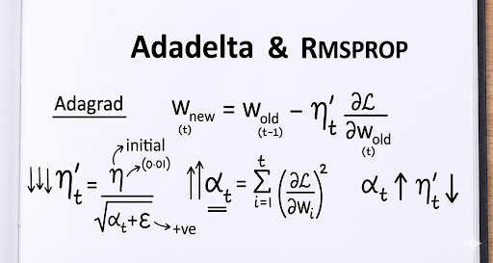

### **2. The Solution: Adadelta & RMSprop**

**Adadelta** and **RMSprop** were developed independently to resolve Adagrad's aggressive decay of the learning rate.

* **Core Idea:** Instead of accumulating *all* past squared gradients (the infinite sum), we restrict the accumulation window.
* **Technique:** We use an **Exponential Weighted Average (Moving Average)** of the squared gradients.

By using a weighted average, we ensure the denominator does not grow infinitely large. The learning rate decreases, but slowly enough to allow convergence.

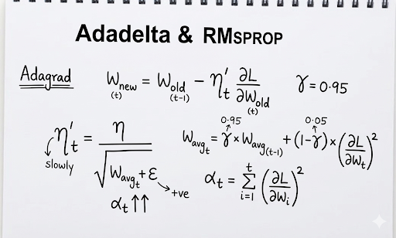

### **3. Mathematical Formulation**

The update process involves three main steps.

#### **Step A: Calculate the Weighted Average (w_{avg})**

Instead of a simple summation, we calculate a running average of the squared gradients. We introduce a decay rate, \gamma (gamma).

* **\gamma (Gamma):** Typically set to **0.95**.
  + This means we retain **95%** of the previous average history.
  + We only add **5%** (1 - 0.95) of the current gradient squared.
* **Effect:** This prevents the gradient accumulation from exploding into a massive number.

#### **Step B: Calculate the New Adaptive Learning Rate (\eta'_t)**

We use the weighted average calculated above in the denominator.

* **\eta:** Initial Learning Rate.
* **\epsilon (Epsilon):** A small positive constant (to prevent division by zero).
* **Result:** Since w_{avg_t} is restricted, \eta'_t decreases **slowly** rather than vanishing rapidly.

#### **Step C: Update the Weights**

Finally, we update the weights using the new adaptive learning rate.

**Visual Reference (Adadelta/RMSprop Formulation):** The image below details the Weighted Average formula and the parameters (Gamma = 0.95). *(From uploaded file: 1765333067551.jpg)*

### **4. Summary Comparison**

| Feature | Adagrad | Adadelta / RMSprop |
| --- | --- | --- |
| **Gradient Accumulation** | Summation of **all** past gradients (\sum). | **Exponential Weighted Average** of past gradients. |
| **Denominator Size** | Grows continuously (can become huge). | Restricted/Bounded by the decay rate \gamma. |
| **Learning Rate Behavior** | Decays very aggressively; can reach 0 too soon. | Decays slowly; allows for sustained learning. |
| **Convergence** | Can stop prematurely (vanishing updates). | Better convergence for deep networks. |

# **📘 Lecture 21 : Adam Optimizer**

# **📘 Lecture 22 : All type of loss**

# **📘 Lecture 23 : Create Artificial Neural Network Using Weight Initialization Tricks**

Done in Colab

<https://github.com/Tamim-saad/DL_practice/blob/master/neural_network.ipynb>

# **📘 Lecture 24 : Keras Tuner Hyperparameter Tuning - How to select hidden layers & number of hidden neurons in ANN**

Done in Colab

<https://github.com/Tamim-saad/DL_practice/blob/master/Hidden_Layers_And_Hidden_Neurons.ipynb>

# **📘 Lecture 25 : Hyper parameter tuning to decide number of hidden layers in NN**

Done in Colab  
<https://github.com/Tamim-saad/DL_practice/blob/master/How_to_Select_how_many_hidden_layer_and_neurons_in_a_neural_network.ipynb>

# 

# **📘 Lecture 26 : How to use GPU (Lagbe na)**

# **📘 Lecture 27 : Introduction to Convolutional Neural Networks (CNNs)**

In this lecture, you begin transitioning from Artificial Neural Networks (ANNs) to Convolutional Neural Networks (CNNs)—the architecture best suited for working with images and video frames.

You highlight that while ANNs work well for regression and classification tasks on structured/tabular data, CNNs are required when dealing with visual data, enabling applications such as:

* Object detection
* Object classification
* Face recognition
* Motion/gesture recognition
* Multi-object recognition

### **How Humans Process Images — Motivation for CNNs**

To explain why CNNs work the way they do, you first describe how the human visual system operates:

1. The back part of the brain contains the Cerebral Cortex, which includes a specialized region called the Visual Cortex.
2. The Visual Cortex has multiple layers, commonly labeled V1, V2, V3, V4, V5, V6.
3. Each layer extracts different types of visual information from what the eyes perceive.

Examples given:

* V1  
   Extracts edges, shapes, simple contours (e.g., outline of a cat).
* V2  
   Extracts slightly more complex information—movement, position of multiple objects (e.g., detecting both cat and dog).
* V4  
   Known for face recognition processing.
* Cross-connections exist (e.g., V1 → V5, V2 → V5), meaning the brain processes visual data in parallel.

The key takeaway:

Each layer of the visual cortex performs a specific operation to extract useful information from the image.

### **Connecting Human Vision to CNNs**

You explain that CNNs are inspired by this visual cortex structure:

* CNN layers act like these V1–V6 layers.
* Instead of biological neurons, CNNs use filters/kernels.
* Each filter extracts a different type of feature:
  + Edges
  + Corners
  + Textures
  + Shapes
  + Object parts
  + Entire object structures

# **📘 Lecture 28 : Lecture Notes: Convolution Operation in CNN**

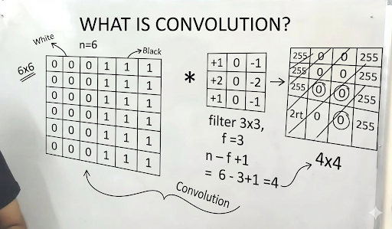

**1. The Goal** The main purpose of the convolution operation in a Convolutional Neural Network (CNN) is **feature extraction**. It transforms an input image to highlight specific patterns, such as edges, textures, or shapes.

**2. Key Components (From the Whiteboard)**

* **Input Image (n \times n):**
  + Represented as a grid of pixel values.
  + **In the image:** A 6 \times 6 matrix (n=6).
  + **Values:** The example uses binary values to represent an image with a clear vertical edge.
    - 0 (labeled "White" in the image).
    - 1 (labeled "Black" in the image).
* **Filter / Kernel (f \times f):**
  + A smaller matrix used to "scan" the image.
  + **In the image:** A 3 \times 3 matrix (f=3).
  + **Specific Filter Shown:**This is a classic **Vertical Edge Detection** filter (similar to a Sobel filter). It responds strongly to changes in contrast from left to right.

**3. The Mathematics**

* **The Operation (*):**
  + You place the filter over the top-left corner of the image.
  + Perform **element-wise multiplication** between the image pixels and the filter values.
  + **Sum** all the results to get a single number.
  + Slide the filter over by one pixel (Stride = 1) and repeat.
* **Output Dimensions:**
  + When you convolve an n \times n image with an f \times f filter (with no padding and stride of 1), the size of the output shrinks.
  + **Formula:** Output size = (n - f + 1) * (n - f + 1)
  + **Calculation from image:**
  + **Result:** The output feature map is a 4 \times 4 matrix.

**4. Interpretation of the Result** The resulting 4 \times 4 matrix is called a **Feature Map** or **Activation Map**.

* High values in this map indicate the presence of the feature (in this case, a vertical edge) at that specific location in the original image.
* The values "255" shown in the output grid on the board likely represent the detected edges after normalization (converting the high mathematical result into a visible pixel value).

# **📘 Lecture 29 : Padding in Convolutional Neural Networks (CNNs)**

**Objective:** Understand the problem of dimensionality reduction in standard convolution and how **Padding** allows us to preserve the spatial dimensions of an image and retain edge information.

### **1. The Problem: Dimensionality Reduction**

In a standard convolution operation, the output feature map is always smaller than the input image.

* **Scenario:**
  + Input Image (n \times n): 6 * 6 pixels.
  + Filter/Kernel (f \times f): 3 * 3 pixels.
* **The Calculation:** Using the standard formula (n - f + 1), the output dimension is:
* **The Result:** The output is a 4 * 4 matrix.
* **The Issue:**
  1. **Loss of Data:** We shrink from 6 \times 6 to 4 \times 4, losing spatial information.
  2. **Border Neglect:** Pixels at the corners and edges are used less frequently in the convolution operation than pixels in the center, leading to a loss of edge information.

### **2. The Solution: Padding**

To solve this, we artificially increase the size of the input image before applying the filter. This technique is called **Padding**.

* **Concept:** Imagine your image is a house. Padding is like building a compound or a border wall around the house.
* **Mechanism:** We add extra rows and columns around the original image.
  + If Padding (p) = 1: We add 1 row to the top, 1 to the bottom, 1 column to the left, and 1 to the right.
  + **New Input Size:** The original 6 \times 6 image effectively becomes an 8 \times 8 image.

### **3. Mathematical Formulation**

When padding is applied, the formula for the output dimension changes to account for the extra pixels (2p, because we add to both sides).

**The Formula:**

Output Dimension = n + 2p - f +1

Where:

* n = Input size
* p = Padding amount
* f = Filter size

**Example Calculation (From the Lecture):**

* **Goal:** We want the output to be the same size as the input (6 \times 6).
* **Input (n):** 6
* **Filter (f):** 3
* **Padding (p):** 1

**Result:** The output is 6 \times 6. We have successfully preserved the original dimensions.

### **4. Types of Padding**

While we can add "empty" pixels, we need to decide what values to fill them with.

#### **A. Zero Padding (Most Common)**

* **Method:** Fill all the padded rows and columns with the value **0**.
* **Benefit:** Simple to implement and computationally efficient. It introduces no new noise (since x \times 0 = 0).

#### **B. Nearest Neighbor / Replication Padding**

* **Method:** Fill the padding with the value of the nearest existing pixel.
  + *Example:* If the edge pixel is 1, the padded pixel next to it becomes 1.
* **Usage:** Less common than zero padding but useful in specific image processing tasks.

### **5. Key Takeaways**

1. **Preservation of Size:** Padding allows us to create deep networks. Without padding, the image would shrink to 1 \times 1 after just a few layers, making deep networks impossible.
2. **Edge Information:** By padding, the original "edge" pixels of the image move toward the interior of the (padded) processing area. This allows the filter to center over them, capturing their information more accurately.
3. **Terminology:**
   * **Valid Convolution:** No padding (p=0). The output shrinks.
   * **Same Convolution:** Padding is chosen specifically so that Output Size = Input Size.

# **📘 Lecture 30 : Operation of CNN (vs ANN)**

**1. ANN vs. CNN: The Basic Difference**

* **ANN (Artificial Neural Network):**
  + In an ANN, inputs (e.g., x_1, x_2, x_3) are multiplied by weights (w_1, w_2, w_3).
  + **Formula:** Z = w_1x_1 + w_2x_2 + w_3x_3 + b (bias).
  + After computing Z, an activation function (like ReLU) is applied: Z' = ReLU(Z) .
* **CNN (Convolutional Neural Network):**
  + Instead of individual inputs, CNNs take an **Image** as input (e.g., a 4 \times 4 matrix of pixel values).
  + Instead of simple weights, CNNs use **Filters** (also called **Kernels**) .

#### **2. The Convolution Operation**

* **Filters/Kernels:**
  + Small matrices (e.g., 2 \times 2 or 3 \times 3) initialized with random values.
  + These filters are used to detect specific features like horizontal or vertical edges .
* **The Math:**
  + The filter is placed over the image (starting at the top-left).
  + Corresponding values are multiplied element-wise and then summed up to get a single value for that position .
  + The filter then slides (strides) over the image to repeat the process.
* **Output Dimensions:**
  + If you apply an f \times f filter on an n \times n image (without padding), the output size is determined by the formula:
    - Output = n - f + 1
  + **Example from video:**
    - Image (n) = 4 \times 4
    - Filter (f) = 2 \times 2
    - Output = 4 - 2 + 1 = 3 (Resulting in a 3 \times 3 matrix) .

#### **3. Activation Function in CNN**

* Just like in ANN, after the convolution operation produces an output map, an activation function (like **ReLU**) is applied to every single value in that output map .
* This introduces non-linearity to the network.

#### **4. How CNNs "Learn" (Backpropagation)**

* In ANN, backpropagation updates the weights (w) to minimize loss.
* In CNN, **the values inside the filters are the weights**.
* During training (backpropagation), the network learns the optimal values for these filters to detect the right features (edges, shapes, etc.) .

#### **5. Hierarchical Learning (Stacking Layers)**

* Convolution layers can be stacked horizontally (Layer 1 \rightarrow Layer 2 \rightarrow ...).
* **Layer 1 (V_1):** Might detect simple features like edges or lines.
* **Layer 2 (V_2):** Combines simple features to detect complex shapes (e.g., eyes, nose).
* **Deeper Layers:** Detect whole objects (e.g., a cat's face) .

#### **6. Key Concept: Location Invariant**

* The video introduces the term "Location Invariant," meaning the network should be able to recognize an object (like a cat) regardless of where it appears in the image.
* This capability is largely handled by the **Max Pooling** layer (to be discussed in the next tutorial) .

# **📘 Lecture 31 : Max Pooling in CNNs**

### **1. Introduction**

**Max Pooling** is a down-sampling operation used in Convolutional Neural Networks (CNNs), typically applied after a convolution layer. Its primary goal is to reduce the spatial dimensions of the input volume (Height \times Width) while retaining the most important information (dominant features).

### **2. Key Concept: Location Invariance**

A critical property of Max Pooling is **Location Invariance** (referenced from Yann LeCun’s research).

* **The Problem:** In an image, a feature (like a cat's face) can appear in various positions.
* **The Solution:** Max Pooling makes the network less sensitive to the exact location of features. If a feature (high pixel intensity) moves slightly, the Max Pooling window will likely still capture that same maximum value, ensuring the feature is detected regardless of small shifts.
* **Result:** As we move deeper into the network (higher layers), the pooling operations help the network recognize "what" is in the image, caring less about exactly "where" it is.

### **3. How Max Pooling Works**

The operation involves sliding a filter window over the input matrix and selecting the **maximum value** within that window.

#### **The Setup (from the lecture example)**

* **Input:** The output of a previous Convolution layer (e.g., a 3 \times 3 matrix).
* **Filter Size (f):** Typically 2 \times 2.
* **Stride (s):** The number of pixels the window shifts. A stride of 2 is common to reduce dimensions by half.

#### **The Calculation**

Given the input matrix from the whiteboard:

[[1,2,3],[4,5,6],[7,8,9]]

We apply a **2 \times 2 Max Pooling filter** with **Stride = 2**.

1. **First Window (Top-Left):**
   * Covers: [[1,2],[3,4]]
   * Operation: max(1, 2, 4, 3)
   * **Result:** 4
2. **Second Window (Shift right by 2):**
   * Covers: [[3 , …],[6 , …]] *(Assuming padding or edge handling)*
   * The lecture example picks the max of the available pixels: \max(3, 6)
   * **Result:** 6
3. **Third Window (Shift down by 2):**
   * Covers: [[2 , 8][… , …]]
   * Operation: max(2, 8)
   * **Result:** 8
4. **Fourth Window (Shift right by 2):**
   * Covers: The remaining pixel [ 4 ]
   * **Result:** 4

**Final Output:**

**[[4 , 6] , [8 , 4]]**

### **4. Why use Max Pooling?**

1. **Feature Preservation:** By taking the maximum value, we preserve the strongest features (e.g., the sharpest edge or the brightest pixel) found by the convolution filters.
2. **Dimensionality Reduction:** It significantly reduces the number of parameters and computations in the network, preventing overfitting and speeding up training.
3. **Noise Suppression:** It ignores lower intensity values (noise), focusing only on the "loudest" signals.

### **5. Other Types of Pooling**

While Max Pooling is the most popular, other variants exist:

* **Average Pooling:** Takes the average value of the window. Used to smooth out the image.
* **Min Pooling:** Takes the minimum value.

### **6. Important Notes on Backpropagation**

* **No Learnable Weights:** Unlike Convolutional layers, Pooling layers do not have weights or biases to learn. They are fixed mathematical operations.
* **Gradient Flow:** During backpropagation, the gradients pass through the pooling layer. The gradient is passed *only* to the neuron that contributed the maximum value during the forward pass (since other values did not affect the output).

# **📘 Lecture 32 : Data Augmentation in CNN**

#### **1. Introduction**

* **Topic:** Data Augmentation in Convolutional Neural Networks (CNN).
* **Problem:** In deep learning, having a small dataset often leads to **overfitting**, where the model memorizes the training data but fails to perform well on new, unseen data (test data).
* **Solution:** Data Augmentation is a technique used to artificially create new training data from existing images by applying various transformations.

#### **2. Key Concepts**

* **Invariance:** The ability of the CNN to recognize an object (e.g., a cat) regardless of its position, orientation, or size in the image.
* **Robustness:** Data augmentation makes the model "robust," meaning it is strong and accurate even when inputs vary or have noise.

#### **3. Techniques Explained**

The lecture highlights several geometric transformations used to generate new samples:

* **Flipping:** Mirroring the image horizontally or vertically.
* **Horizontal Shifting:** Moving the image pixels along the X-axis.
* **Vertical Shifting:** Moving the image pixels along the Y-axis.
* **Zooming:** Randomly zooming in or out on the subject.
* **Rotation:** Rotating the image by a certain degree (e.g., 30°, 90°).

#### **4. Practical Example (From the Whiteboard)**

* **Scenario:** A classification task to distinguish between **Dogs & Cats**.
* **Initial Data:** Suppose you have a dataset \{x_i, y_i\} with 500 images of cats and 500 images of dogs.
* **Applying Augmentation:**
  + If you apply a "flip" or "shift" to the 500 cat images, you generate new variations.
  + By creating 10 variations per image, you expand your dataset from **500 images → 5,000 images**.
* **Result:** The CNN gets trained on 5,000 diverse images instead of just 500 similar ones, significantly improving accuracy and reducing overfitting.

#### **5. Summary Flowchart**

**Input Image** (e.g., Cat face) \rightarrow **Apply Transformations** (Flip, Shift, Zoom) \rightarrow **Augmented Dataset** \rightarrow **CNN Model** \rightarrow **Output** (Robust Prediction)

# **📘 Lecture 33 : Data Augmentation Coding session using Keras**

colab

# **📘 Lecture 34 :**